Vice-Chair of the Standing Northern Ireland Committee

Contributor candidate pack
01 | Welcome

It’s a pleasure to welcome you as you explore the opportunity to contribute to the work of the Royal College of Radiologists. I’m delighted that you’re considering joining our committed community of professionals who contribute their time, skills and experience to support our work.
At the RCR, colleagues like you are absolutely vital to the work we do. You play a key role in helping us support excellence in medical imaging, interventional radiology and cancer treatment - both now and in the future. In contributing your time, expertise, and perspective, your involvement strengthens our impact and supports the delivery of safe, high-quality patient care, which sits at the heart of everything we do.
As a Contributor, you will help us deliver the College’s strategic priorities, including providing excellent standards and guidance for the workforce, delivery of high-quality professional learning, and being recognised as the experts in our fields. Your insight and involvement help ensure that our specialties continue to grow in both strength and influence.
Many of our Contributors have told us they choose to give their time because they want to make a real difference to our specialties. And by getting involved, they’ve also found opportunities to build lasting professional networks and stay connected with peers across the UK and beyond. The same will be true for you.
We’re proud to be a college that works in partnership with its members. Our Contributors bring energy, ideas, and commitment that shape our work and our future - and we are stronger because of it.
I look forward to the opportunity to work with you.

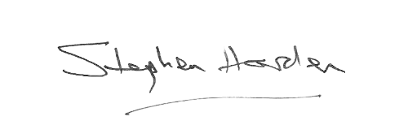
With warm wishes,

Dr Stephen Harden
President of The Royal College of Radiologists

02 | Role Summary

Role title: | Vice-Chair of the Standing Northern Ireland Committee
Time Commitment: | Term of Office is three years, and may be extended by a second term of three years as Chair
Location: | Remote
Closing date for applications: | 6th March 2026

Why this role exists
The Standing Northern Ireland Committee (SNIC) provides advice and guidance to the Trustee Board on the issues concerning Clinical Radiologists and Clinical Oncologists specifically within Northern Ireland. It is also the means by which the Royal College of Radiologists (RCR) can provide tailored support to its members in Northern Ireland.

Your impact
The SNIC has four overarching purposes:
- To provide advice and guidance to the Trustee Board on issues concerning Clinical Radiologists and Clinical Oncologists specifically within Northern Ireland
- To provide a means for the RCR to provide support to its members and the specialties in Northern Ireland
- To give voice to the RCR in Northern Ireland
- To inform a four-nations’ view on College work

Each appointed member has the responsibility of ensuring that the views and concerns of the clinical oncologists or clinical radiologists in their regions are relayed to the Standing Northern Ireland Committee, which in turn feeds back to RCR.

03 | Key responsibilities and requirements

A Fellow or member in good standing, applying for appointment to the Committee as Vice-Chair must have the knowledge and experience of Clinical Radiology/Clinical Oncology and be able to demonstrate an interest in and experience of at least some of the following attributes and areas of practice:

Knowledge, qualifications and experience | Essential (E) or Desirable (D)
Hold a current licence to practise in the UK, practising in Northern Ireland  and have the majority of their sessions within the relevant region | E
Experience of working in one or more of the following: District General Hospital, Regional Centre, or Teaching Hospital | E
Experience of training, management, or governance within Clinical Radiology / Clinical Oncology | E
Skills and abilities
A commitment to abide by the Contributor Code of Conduct. | E
Good interpersonal skills and a proven ability to work in a Committee setting | E

Other Requirements
All RCR board and committee members are expected to demonstrate adherence to the College values & strategy. All board and committee members will be required to declare any conflicts at the beginning of every meeting in accordance with the conflicts of interest policy.

04 | Commitment and conditions

Contributors at the RCR play an essential role in supporting the College’s strategic initiatives and shaping the direction of the College. Although our Contributor positions are undertaken on a voluntary basis, each role has optimal impact when Contributors dedicate sufficient time to fulfilling the responsibilities entrusted to them.
Term of Office
The Vice-Chair of the Standing Northern Ireland Committee will be a Fellow practising in Northern Ireland and will be appointed by the Vice-Presidents of the RCR. The term of office of the Vice-Chair is three years, with a second term of three years should they be appointed Chair following their service as Vice-Chair. It is usual that following the Vice-Chair’s term of office, they will become the Chair of the Committee. However, this is always subject to the agreement of the respective Faculty Officers of RCR.
Meetings
There will normally be three meetings of the Standing Northern Ireland Committee per year. The College has adapted to remote meetings, and these are held generally in January and September/October with one face-to-face meeting per year in May/June.

The Chair and Vice-Chair of the Standing Northern Ireland Committee are ex-officio members of their respective Faculty Board and the Council and are expected to attend two meetings annually of each Board. Should the Chair and Vice-Chair be from the same Faculty then only one will be the ex-officio member of the Boards and a nominee from the other Faculty should be identified to join their respective Faculty Board and Council.
Other responsibilities
The Chair and Vice-Chair of the Standing Northern Ireland Committee are also responsible for the appointment of the appointed members, in line with standard RCR appointment processes. This includes the appointment of Resident doctor members. Consideration must be given to the spread of geographical representation of the appointed members.
Outside of these commitments, the general duties of the Vice-Chair will include:
- Sitting in for the Chair when required.
- Leading the work of the Committee and ensuring that the Terms of Reference are observed.
- Engaging all members of the Committee in the Committee’s work.
- Ensuring that relevant matters are drawn to the attention of the appropriate Faculty Vice-President of the College, and other Officers, and the Faculty Board where necessary.
- Working with relevant College staff regarding the administration of the Committee including responding to queries in between meetings.

05 | Support and benefits of the role

Support provided to the role
The RCR will offer you strong support, ensuring that you are informed, feel valued, and are equipped to fulfil your role.
This includes:
- comprehensive administrative support tailored to your role, facilitated by a key RCR staff contact,
- key contacts within the Governance and Executive teams,
- regular engagement opportunities with RCR staff and fellow Contributors,
- RCR's Contributor Officer, providing high-level support for all Contributors,
- the Contributor Code of Conduct and Contributor Handbook, which provide reassurance around our expectations of conduct and personal integrity,
- the opportunity to attend induction sessions, providing you with all relevant information to fulfil your role effectively.
Benefits of the role
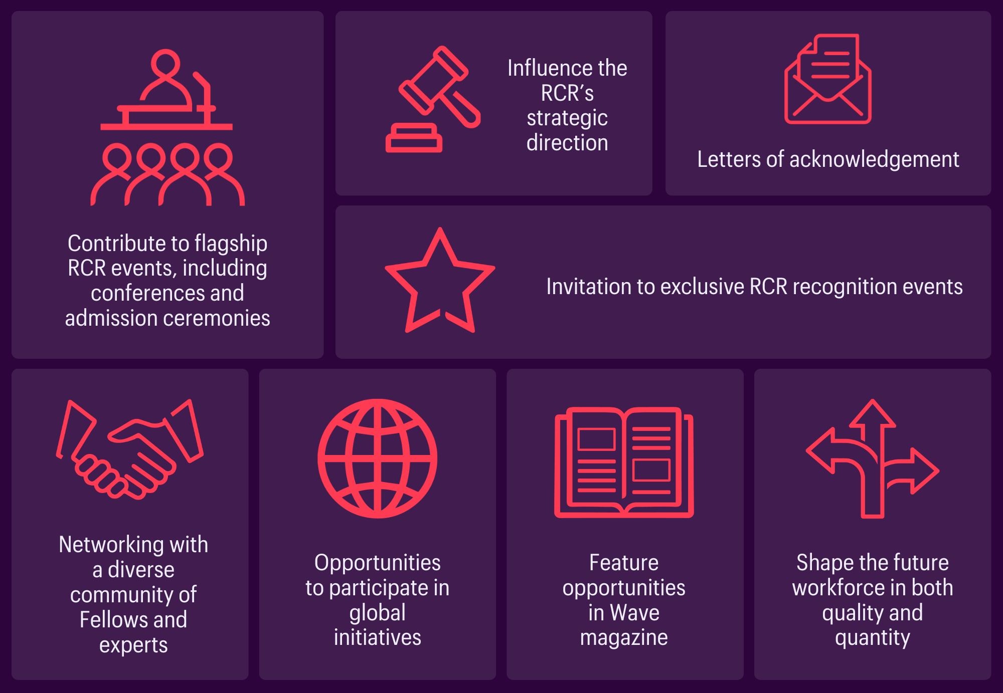

06 | Application process

How to apply
Applicants are asked to submit a short CV and a brief statement outlining their relevant experience and interests, and how these meet the attributes listed above.

Please submit your application to the Governance Assistant by 5pm on Friday 6th March 2026.

Applications will be assessed by the Chair of the Standing Northern Ireland Committee in consultation with the Vice-Presidents of the RCR.

Our commitment to Equality, Diversity, and Inclusion
We are committed to actively fostering an inclusive culture at the RCR. We uphold a commitment to building a Contributor group that reflects the diversity of our global community, and therefore we actively welcome applications from individuals from under-represented groups and diverse backgrounds. We are also dedicated to making reasonable adjustments, for example, offering documents in alternative formats to accommodate neurodiversity. If you would like to discuss this further, please contact the Contributor Officer: contributors@rcr.ac.uk

Important information for Contributors
- We encourage you to explore the Contributor Code of Conduct and Contributor Handbook.
- We request that all applicants complete our EDI Monitoring Form. The information you provide anonymously will help us to understand how our Contributor group represents a diverse range of experience, views and backgrounds. Please complete the form by clicking this link: EDI Monitoring Form for Applicants to Contributor Roles
- All data will be handled in accordance with our data protection policy and membership privacy notice.
- Please note that you may be required to complete a ‘Declaration of conflict of interest’ form.
- For more general queries about the role of an RCR Contributor, please email contributors@rcr.ac.uk


“It’s a great network of colleagues and individuals who share similar interests in education and training.”
“One of the best things I do! Great group of colleagues.”
“An opportunity to work with some inspirational individuals & learn a lot about our specialty.”
“I found it interesting, personally developmental and hugely collaborative.”

The Royal College of Radiologists 63 Lincoln’s Inn Fields
London, WC2A 3JW, UK
The Royal College of Radiologists
is a Charity registered with the
Charity Commission No 211540.

© The Royal College of Radiologists, October 2025.



