RadReach Steering

Group Member

Contributor candidate pack
01 | Welcome

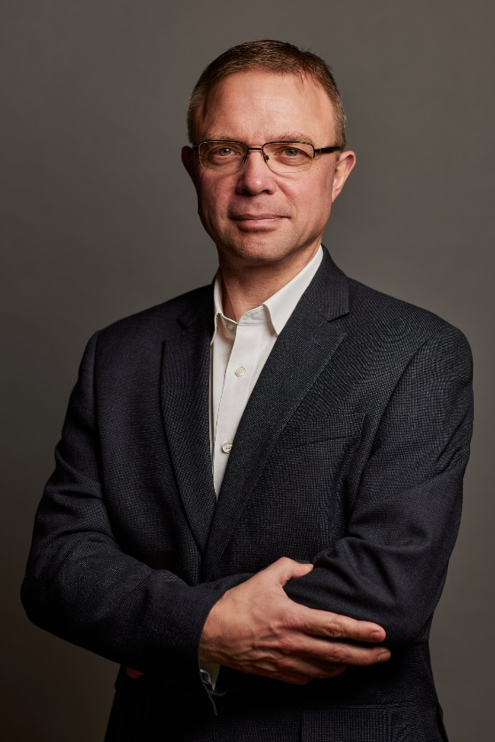
It’s a pleasure to welcome you as you explore the opportunity to contribute to the work of the Royal College of Radiologists. I’m delighted that you’re considering joining our committed community of professionals who contribute their time, skills and experience to support our work.
At the RCR, colleagues like you are absolutely vital to the work we do. You play a key role in helping us support excellence in medical imaging, interventional radiology and cancer treatment - both now and in the future. In contributing your time, expertise, and perspective, your involvement strengthens our impact and supports the delivery of safe, high-quality patient care, which sits at the heart of everything we do.
As a Contributor, you will help us deliver the College’s strategic priorities, including providing excellent standards and guidance for the workforce, delivery of high-quality professional learning, and being recognised as the experts in our fields. Your insight and involvement help ensure that our specialties continue to grow in both strength and influence.
Many of our Contributors have told us they choose to give their time because they want to make a real difference to our specialties. And by getting involved, they’ve also found opportunities to build lasting professional networks and stay connected with peers across the UK and beyond. The same will be true for you.
We’re proud to be a college that works in partnership with its members. Our Contributors bring energy, ideas, and commitment that shape our work and our future - and we are stronger because of it.
I look forward to the opportunity to work with you.


With warm wishes,

Dr Stephen Harden
President of The Royal College of Radiologists

02 | Role Summary

Role title: | RadReach Steering Group Member  1 x clinical radiology member or Fellow  1 x clinical oncology member or Fellow  1 x current or former RadReach mentee
Time Commitment: | 3 years
Location: | Hybrid – with some attendance at Royal College of Radiologists in London
Closing date for applications: | 22nd May 2026

Background
A paper by the GMC in 2020 found that doctors from ethnic minority backgrounds were being found to be less appointable to speciality training jobs than white doctors. RadReach was set up in 2021 to encourage and promote inclusion and equity across clinical radiology and clinical oncology.
There are four pillars which make up the RadReach programme:
- Outreach- ensuring individuals in education settings are aware of national organisations like Widening Participation Medics Network, IR Juniors and other local ones to support them as they navigate the work experience, application and education phase.
- Mentoring- RadReach will support them through mentoring pairing them with an experienced mentor.
- Representation- mentoring and coaching will increase confidence and exposure to opportunities. This includes but is not limited to ensuring diversity in the clinical environment, training and education roles, external events and conferences and representation on boards and committees.
- Leadership- so that those in leadership positions may truly reflect the population served.
Over the last 5 years RadReach has continued to expand its reach, strengthened its infrastructure and deepened its impact. 120 mentees have gone through the mentoring programme with 42 gone on to secure speciality training positions. Our steering group members, patrons and ambassadors have spoken about RadReach at national conferences further raising the profile of the initiative. Through the introduction of the RCR mentoring platform we have been able to support increased number of mentees. The continued partnership with IR Juniors, RCR Fairer Training Fellows and Widening Participation Medics Network has enriched the offer further.

The role
The RadReach chair leads the initiative, supported by a steering group. Together they will discuss, plan and agree the annual programme of activity for RadReach including the annual engagement day, regular webinars and activities and mentoring cohort.
RadReach is supported by the Professional Networks team at the RCR.
The steering group is made up of a range of individuals across both facilities ensuring representation at all career stages. We are currently recruiting for the following positions:
- Clinical Oncology member/Fellow
- Clinical Radiology member/Fellow
- Current or previous RadReach mentee

03 | Key responsibilities and requirements

The RadReach Steering Group will:
- Ensure there is effective oversight of RadReach activities
- Contribute views and support the development of RadReach programme.
- Plan, deliver and evaluation the programme for the annual RadReach engagement day- usually in February/March.
- Promote the mentoring programme across networks to ensure a sufficient number and range of diverse applications
- Review, promote and assist with scoring of applications – usually in June
- Review the impact of RadReach and contribute meaningfully to the annual impact report. .
- Review the key stakeholders in the RadReach programme and identify
appropriate means of engaging with them.

- Identify and approach suitable patrons to support the work and profile of RadReach on a national and international stage across professional and personal networks
- Maintain confidentiality and comply with GDPR.
- Attend three meetings per year (virtual unless required) and on occasion respond via electronic to support decisions for the advancement of RadReach.

Knowledge, qualifications and experience | Essential (E) or Desirable (D)
Understanding of equity, diversity and inclusion (EDI) principles | E
Be a Fellow of the RCR currently practising clinical radiology or clinical oncology in the UK | E
Demonstrable interest in mentoring | E
Leadership experience | D
Experience supporting people with widening participation criteria or underrepresented groups | D
Skills and abilities
A commitment to abide by the Contributor Code of Conduct. | E
Good interpersonal skills and a proven ability to work in a network setting | E
Teamwork, collaboration and engagement | E
Commitment to fairness, inclusion and improving training experiences | E
Clear verbal and written communication | E
Creativity and willingness to explore new ideas | E

Other Requirements
In appointing members of the Steering Group, consideration will be given to candidates’ lived experience of one or more widening participation characteristics, and their ability to demonstrate a commitment to widening participation in our specialties.

Widening participation characteristics may include, but are not limited to lived experience of underrepresentation relating to:

- ​ethnicity (including people from ethnic minority backgrounds¹)
- special educational needs (SEN)
- disability
- speaking English as an additional language
- being estranged from both parents or guardians
- being in care or otherwise in need
- caring responsibilities
- coming from a background where neither parent is in a skilled profession
- coming from a background where neither parent has attended university
- experience of economic disadvantage, including eligibility for free school meals
- being an international medical graduate currently working in the UK.

¹ We recognise that language relating to ethnicity is evolving and that people and communities may use valid different terms to describe their identities. For the purposes of this initiative, and in line with Office for National Statistics guidance, this document uses the term “people from ethnic minority backgrounds” to support a shared understanding, referring to ethnic groups other than White British. This terminology is used as a practical classification rather than a statement about identity, and is adopted to maintain consistency with national data standards and reporting frameworks.

04 | Commitment and conditions

Contributors at the RCR play a vital role in supporting the College’s initiatives and driving its progress. Although our Contributor positions are undertaken on a voluntary basis, each role has optimal impact when Contributors dedicate sufficient time to fulfilling the responsibilities entrusted to them.
Members of the RadReach steering group are expected to attend quarterly Steering Group meetings per year and to be available to make decisions made electronically between meetings.
Members must uphold the Steering Group’s purpose and Terms of Reference, support RadReach’s mentoring, outreach and professional development activities, and actively promote the programme within their networks.

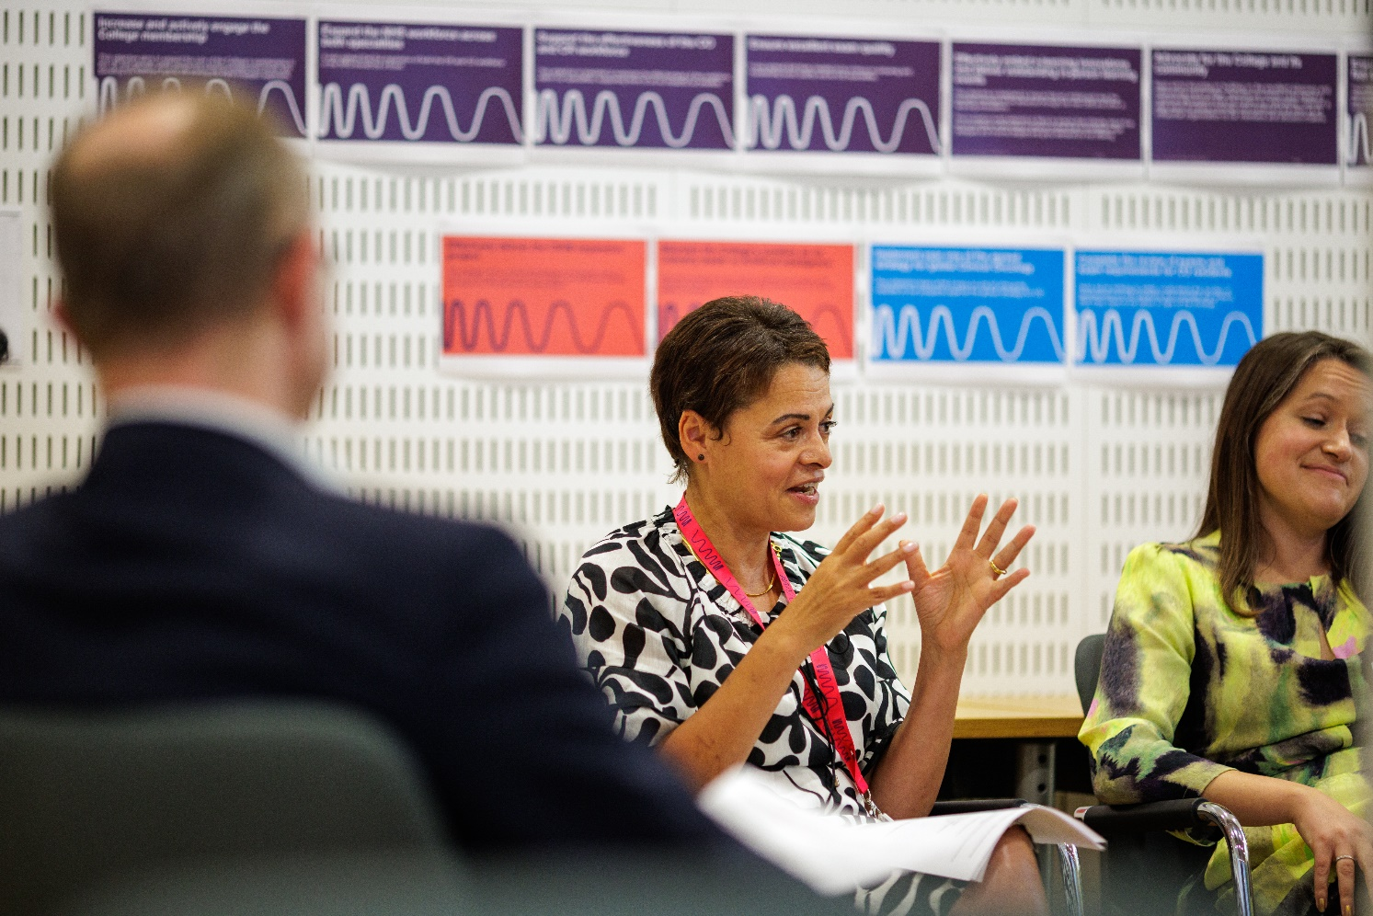

05 | Support and benefits of the role

Support provided to the role
The RCR will offer you strong support, ensuring that you are informed, feel valued, and are equipped to fulfil your role.
This includes:
- information and administrative support provided by Professional Networks Team
- regular engagement opportunities with RCR staff and fellow Contributors,
- RCR's Contributor Officer, providing high-level support for all Contributors,
- the opportunity to attend induction sessions, providing you with all relevant information to fulfil your role effectively,
- the Contributor Code of Conduct and Contributor Handbook, which provide reassurance around our expectations of conduct and personal integrity.
Benefits of the role
Joining the RadReach Steering Group:
- Offers a valuable opportunity to contribute to meaningful change within clinical radiology and clinical oncology.
- Strengthens leadership, collaboration and communication skills, provides visibility for your commitment to widening participation
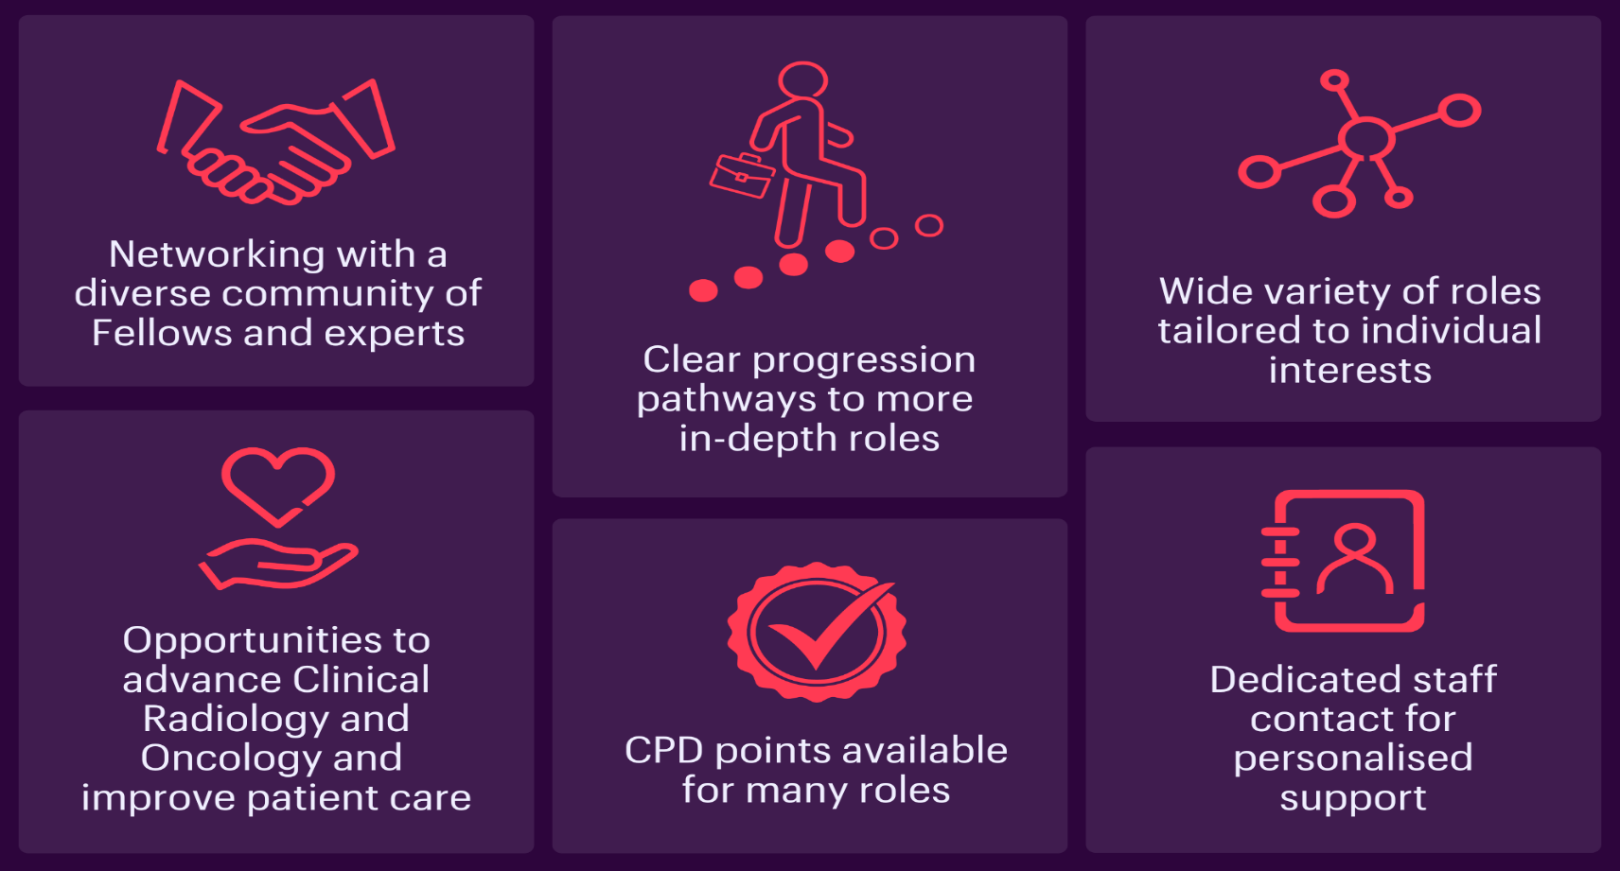
- Enhances your portfolio through involvement in mentoring, outreach and professional development initiatives.

06 | Application process

How to apply
Please submit a CV and brief covering letter as to why you would like to join the RadReach steering group to radreach@rcr.ac.uk by Friday 22nd May 2026.

Our commitment to Equality, Diversity, and Inclusion
We are committed to actively fostering an inclusive culture at the RCR. We uphold a commitment to building a Contributor group that reflects the diversity of our global community, and therefore we actively welcome applications from individuals from under-represented groups and diverse backgrounds. We are also dedicated to making reasonable adjustments, for example, offering documents in alternative formats to accommodate neurodiversity. If you would like to discuss this further, please contact the Contributor Officer: contributors@rcr.ac.uk

Important information for Contributors
- We encourage you to explore the Contributor Code of Conduct and Contributor Handbook.
- We request that all applicants complete our EDI Monitoring Form. The information you provide anonymously will help us to understand how our Contributor group represents a diverse range of experience, views and backgrounds. Please complete the form by clicking this link: EDI Monitoring Form for Applicants to Contributor Roles
- All data will be handled in accordance with our data protection policy and membership privacy notice.
- Please note that you may be required to complete a ‘Declaration of conflict of interest’ form.
- For more general queries about the role of an RCR Contributor, please email contributors@rcr.ac.uk


“It’s a great network of colleagues and individuals who share similar interests in education and training.”
“One of the best things I do! Great group of colleagues.”
“An opportunity to work with some inspirational individuals & learn a lot about our specialty.”
“I found it interesting, personally developmental and hugely collaborative.”

The Royal College of Radiologists 63 Lincoln’s Inn Fields
London, WC2A 3JW, UK
The Royal College of Radiologists
is a Charity registered with the
Charity Commission No 211540.

© The Royal College of Radiologists, October 2025.



