RadReach Chair

Contributor candidate pack
01 | Welcome

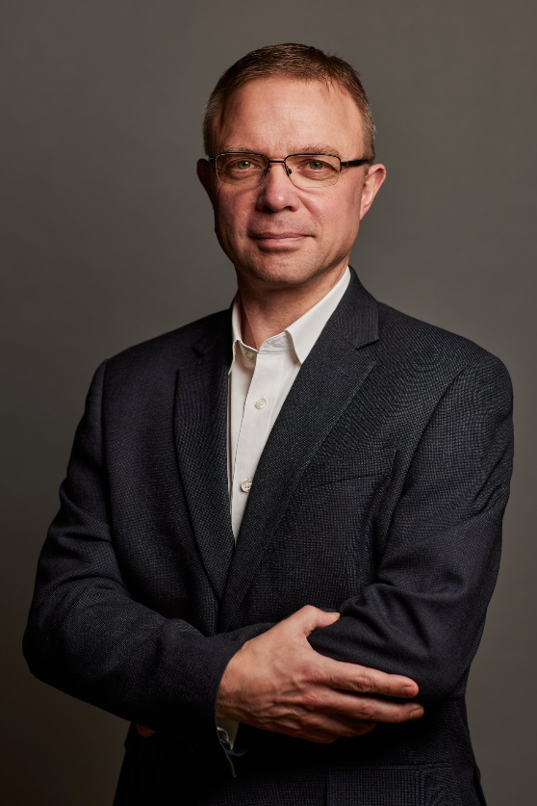
It’s a pleasure to welcome you as you explore the opportunity to contribute to the work of the Royal College of Radiologists. I’m delighted that you’re considering joining our committed community of professionals who contribute their time, skills and experience to support our work.
At the RCR, colleagues like you are absolutely vital to the work we do. You play a key role in helping us support excellence in medical imaging, interventional radiology and cancer treatment - both now and in the future. In contributing your time, expertise, and perspective, your involvement strengthens our impact and supports the delivery of safe, high-quality patient care, which sits at the heart of everything we do.
As a Contributor, you will help us deliver the College’s strategic priorities, including providing excellent standards and guidance for the workforce, delivery of high-quality professional learning, and being recognised as the experts in our fields. Your insight and involvement help ensure that our specialties continue to grow in both strength and influence.
Many of our Contributors have told us they choose to give their time because they want to make a real difference to our specialties. And by getting involved, they’ve also found opportunities to build lasting professional networks and stay connected with peers across the UK and beyond. The same will be true for you.
We’re proud to be a college that works in partnership with its members. Our Contributors bring energy, ideas, and commitment that shape our work and our future - and we are stronger because of it.
I look forward to the opportunity to work with you.


With warm wishes,

Dr Stephen Harden
President of The Royal College of Radiologists
Reflection from current chair- Dr Anu Obaro

“It’s been an immense privilege to work with the College. Seeing resident doctors getting into medicine and into our specialities is just wonderful. My time as Chair as been full of laughs and breakthroughs. It’s been about connection, advocacy and championing people who often don’t have anyone in their corner to encourage them. It’s been the most incredible experience.”
02 | Role Summary

Role title: | RadReach Chair
Time Commitment: | 3 years
Location: | Remote – with encouragement to contribute to delivery of our annual RadReach engagement event and other RCR events, usually held in London
Closing date for applications: | Friday 22nd May 2026

Background
A paper by the GMC in 2020 found that doctors from ethnic minority backgrounds were being found to be less appointable to speciality training jobs than white doctors. RadReach was set up in 2021 to encourage and promote inclusion and equity across clinical radiology and clinical oncology.
There are four pillars which make up the RadReach programme:
- Outreach- ensuring individuals in education settings are aware of national organisations like Widening Participation Medics Network, IR Juniors and other local ones to support them as they navigate the work experience, application and education phase.
- Mentoring- RadReach will support them through mentoring pairing them with an experienced mentor.
- Representation- mentoring and coaching will increase confidence and exposure to opportunities. This includes but is not limited to ensuring diversity in the clinical environment, training and education roles, external events and conferences and representation on boards and committees.
- Leadership- so that those in leadership positions may truly reflect the population served.
Over the last 5 years RadReach has continued to expand its reach, strengthened its infrastructure and deepened its impact. 120 mentees have gone through the mentoring programme with 42 gone on to secure speciality training positions. Our steering group members, patrons and ambassadors have spoken about RadReach at national conferences further raising the profile of the initiative. Through the introduction of the RCR mentoring platform we have been able to support increased number of mentees. The continued partnership with IR Juniors, RCR Fairer Training Fellows and Widening Participation Medics Network has enriched the offer further.
Purpose of the role
To provide leadership of RadReach, quality oversight and advice for the development, delivery and evaluation of the RadReach initiative.
The RadReach chair will lead the Steering group and the annual RadReach engagement day. The Chair will be supported by the Professional Networks team who administer the operational delivery of the College’s mentoring offer.
RadReach is open to members and Fellows across both of the RCR’s Faculties – clinical oncology and clinical radiology. We would welcome a Chair who is comfortable working across both specialties.

03 | Key responsibilities and requirements

Key Responsibilities
Leadership and developmental oversight
- Plan, deliver and evaluate a robust annual programme of events for the RadReach community including the annual engagement day
- Provide coherent oversight across RadReach considering how the RCR can facilitate a consistently high-quality experience
- Lead the steering group
- Provide ideas and recommendations for scaling or adapting new delivery options to meet emerging member needs
- Write reports to RCR boards and committees as required on progress and future plans for RadReach
Profile, impact and engagement
- Act as an ambassador for RadReach within and beyond the RCR, supporting outreach and engagement across the UK
- Champion the work of RadReach at senior board and committee level across the RCR.
- Support recruitment and retention of mentors and mentees
- Support communication campaigns and represent RadReach at relevant events and forums
- Advise on strategic initiatives affecting mentoring, including equality, diversity and inclusion priorities
- Support the Fairer Training Fellows who lead on the reverse mentoring programme ensuring appropriate experience and representation at RadReach

Knowledge, qualifications and experience | Essential (E) or Desirable (D)
Be a Fellow of the RCR currently practising clinical radiology or clinical oncology in the UK | E
Demonstrable leadership experience | E
Understanding of equality, diversity and inclusion (EDI) principles and demonstrable commitment to tackling structural inequalities | E
Demonstrable participation in mentoring | E
Experience supporting people from a widening participation background or from otherwise underrepresented groups | D
Skills and abilities
A commitment to abide by the Contributor Code of Conduct. | E
Good interpersonal skills | E
Ability to inspire engagement and participation from peers and stakeholder | E
Ability to evaluate information and use it to make practical recommendations | E
Clear verbal and written communication | E

04 | Commitment and conditions

Contributors at the RCR play an essential role in supporting the College’s strategic initiatives and shaping the direction of the College. Although our Contributor positions are undertaken on a voluntary basis, each role has optimal impact when Contributors dedicate sufficient time to fulfilling the responsibilities entrusted to them.
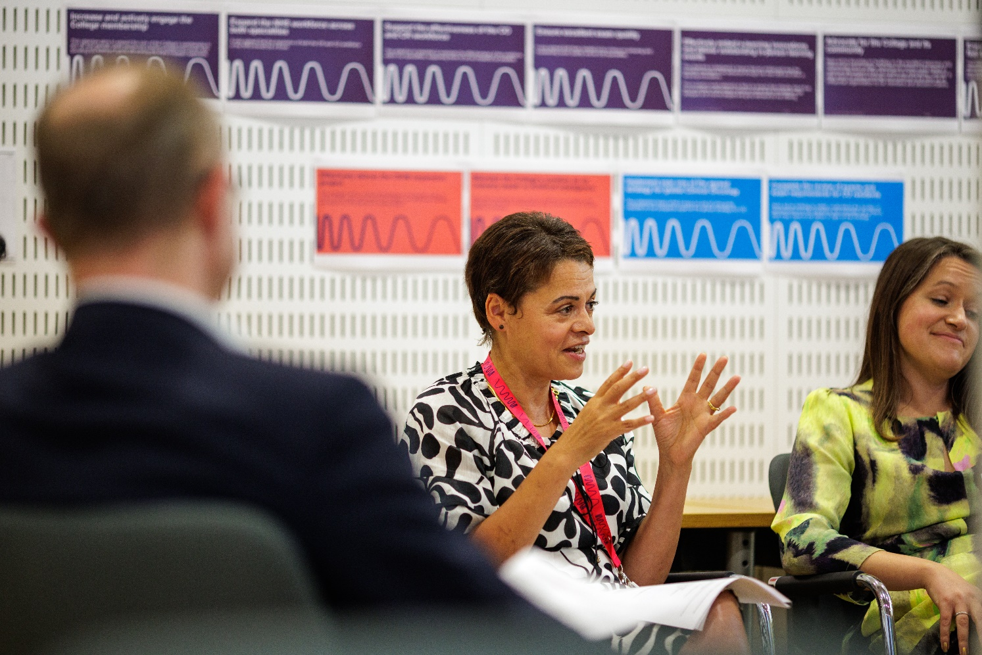
The time commitment for this role is expected to be 1-2 hours a week on average. The role will involve some variation across the year, with occasional periods of increased activity during planning for engagement day, mentor/mentee recruitment cycles, matching and any other key periods.

05 | Support and benefits of the role

Support provided to the role
The RCR will offer you strong support, ensuring that you are informed, feel valued, and are equipped to fulfil your role.
This includes:
- information and administrative support provided by Professional Networks team
- regular engagement opportunities with RCR staff and fellow Contributors,
- RCR's Contributor Officer, providing high-level support for all Contributors,
- the opportunity to attend induction sessions, providing you with all relevant information to fulfil your role effectively,
- the Contributor Code of Conduct and Contributor Handbook, which provide reassurance around our expectations of conduct and personal integrity.
Benefits of the role
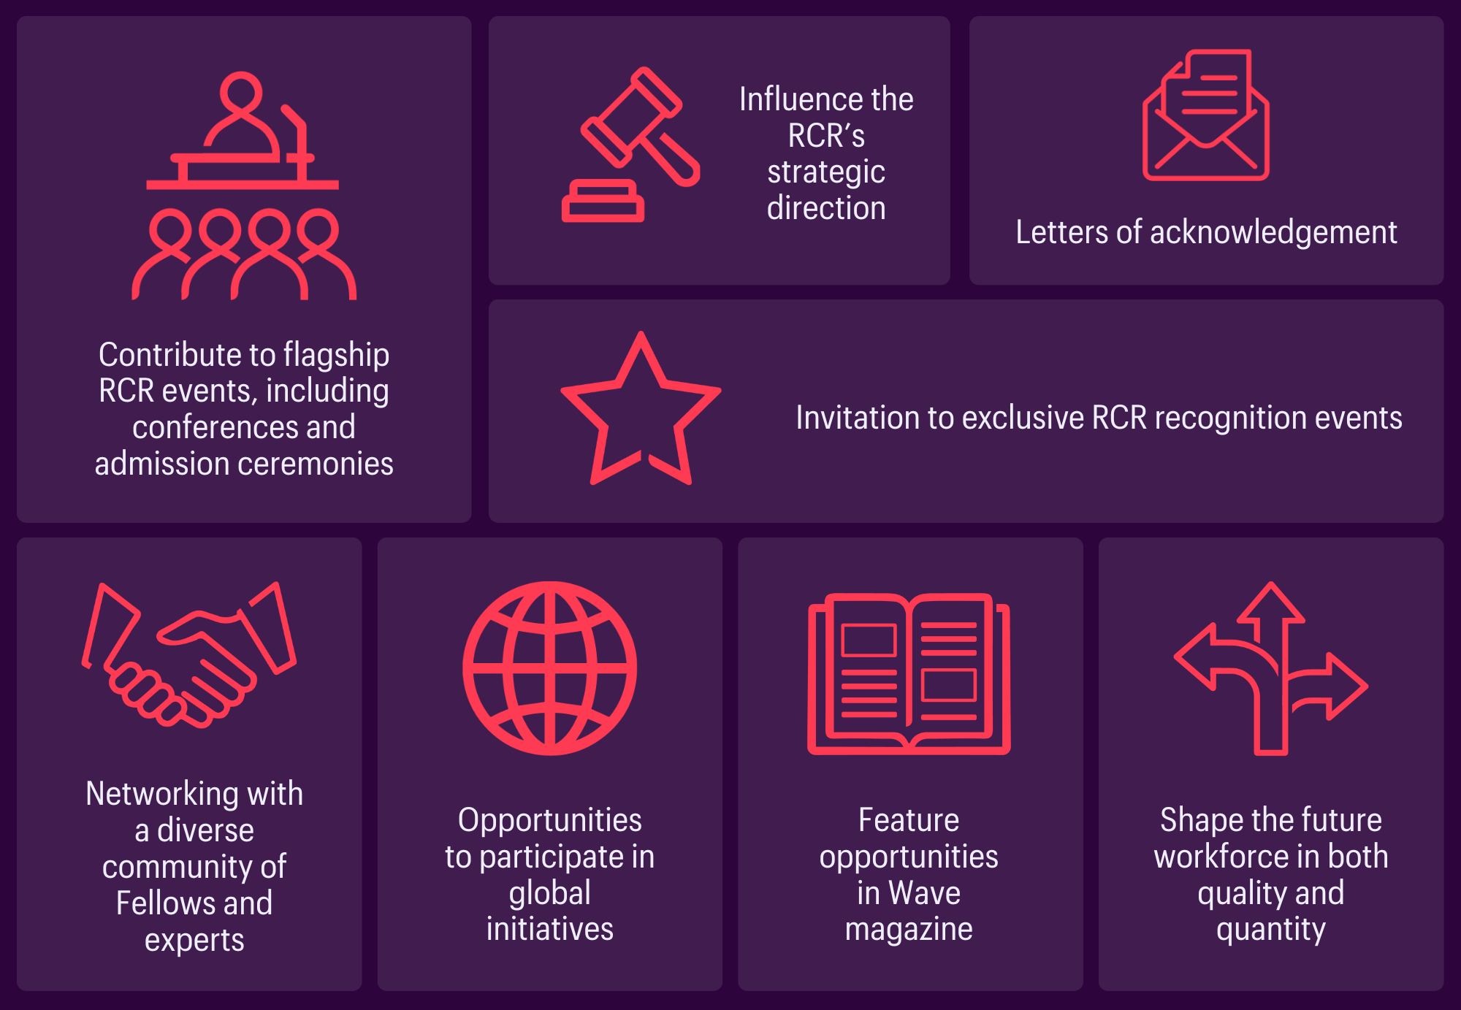

06 | Application process

How to apply

Please submit a CV and brief covering letter to RadReach@rcr.ac.uk by Friday 22nd May 2026.

Our commitment to Equality, Diversity, and Inclusion
We are committed to actively fostering an inclusive culture at the RCR. We uphold a commitment to building a Contributor group that reflects the diversity of our global community, and therefore we actively welcome applications from individuals from under-represented groups and diverse backgrounds. We are also dedicated to making reasonable adjustments, for example, offering documents in alternative formats to accommodate neurodiversity. If you would like to discuss this further, please contact the Contributor Officer: contributors@rcr.ac.uk

Important information for Contributors
We encourage you to explore the Contributor Code of Conduct and Contributor Handbook.
We request that all applicants complete our EDI Monitoring Form. The information you provide anonymously will help us to understand how our Contributor group represents a diverse range of experience, views and backgrounds. Please complete the form by clicking this link: EDI Monitoring Form for Applicants to Contributor Roles
All data will be handled in accordance with our data protection policy and membership privacy notice.
Please note that you may be required to complete a ‘Declaration of conflict of interest’ form.
For more general queries about the role of an RCR Contributor, please email contributors@rcr.ac.uk


“It’s a great network of colleagues and individuals who share similar interests in education and training.”
“One of the best things I do! Great group of colleagues.”
“An opportunity to work with some inspirational individuals & learn a lot about our specialty.”
“I found it interesting, personally developmental and hugely collaborative.”

The Royal College of Radiologists 63 Lincoln’s Inn Fields
London, WC2A 3JW, UK
The Royal College of Radiologists
is a Charity registered with the
Charity Commission No 211540.

© The Royal College of Radiologists, October 2025.



