Resource Author

Contributor candidate pack
01 | Role Summary

Role title: | Resource Author
Time Commitment: | The tenure for this role will be 3 years.  This voluntary role offers flexible involvement, with time commitments varying by project. We’ll always discuss expectations upfront for each resource being developed, and work with you to ensure the level of contribution fits your availability and remains flexible and manageable.
Location: | London, United Kingdom
Closing date for applications: | Open-ended

Why this role exists
The Royal College of Radiologists (RCR) is redeveloping its e-learning library to support lifelong learning for Fellows and members worldwide. Our new platform, RCR Learn, will offer a curated selection of high-quality, interactive educational resources across clinical radiology and oncology specialties. As a resource author, you will play a vital role in designing, writing, reviewing, and quality-assuring e-learning resources aligned with specialty curricula and strategic priorities.

Your impact
As a Resource Author, you will be part of a collaborative, supportive faculty working to develop high-quality e-learning for the RCR. You will work closely with Sub-Specialty and Site-Specialty Leads, digital learning designers and fellow authors to shape clinically accurate, engaging e-learning resources aligned with the curriculum.
This voluntary role offers the opportunity to share your subject matter expertise, develop digital learning skills and contribute meaningfully to the professional development of colleagues, while gaining recognition, experience and connections across the RCR Learning community.

02 | Key responsibilities and requirements

As a Resource Author, you will play a key role in the development of high-quality e-learning resources for RCR Learning. Working collaboratively with Sub-Specialty and Site-Specialty Leads, as well as the RCR Learning and Learning Design teams, you will help scope, write, review, and refine clinical content within your area(s) of expertise. You will ensure that all materials are accurate, up-to-date, curriculum-aligned, and presented in a clear, engaging format suitable for a digital learning environment. You will also contribute to quality assurance processes by reviewing draft resources and providing constructive feedback, supporting the delivery of consistent, learner-focused educational content.

Knowledge, qualifications and experience | Essential (E) or Desirable (D)
Clinical expertise and a deep subject knowledge and interest in a relevant site-speciality or sub-speciality | E
Experience, enthusiasm, and/or strong interest in medical education | E
Understanding of postgraduate medical training and curricula | E
Previous authorships or peer-review of educational material | D
Experience of curriculum mapping and of assessment design | D
Experience of contributing to, reviewing, curating, and improving e-learning or digital educational resources | D
Skills and abilities
A commitment to abide by the Contributor Code of Conduct. | E
Ability to communicate complex clinical concepts clearly and concisely | E
Strong written communication skills | E
Ability to work collaboratively as part of a multidisciplinary team, and to meet agreed deadlines | E
Familiarity with digital learning platforms and online content formats | D

Other Requirements
In addition to the knowledge, experience, skills, and abilities outlined above, Resource Authors are expected to meet a few practical and professional requirements to support effective collaboration and the timely delivery of high-quality e-learning resources:
- Willingness to contribute on a voluntary basis and commit sufficient time to meet agreed project timelines and milestones.
- Ability to work flexibly and responsively within a structured development process, incorporating feedback from clinical leads and learning designers.
- Commitment to equality, diversity, and inclusion, ensuring learning resources are accessible and relevant to a diverse learner audience.

03 | Commitment and conditions

Contributors play an important role in supporting the activities and initiatives of the College. Although our Contributor positions are undertaken on a voluntary basis, each role has optimal impact when Contributors dedicate sufficient time to fulfilling the responsibilities entrusted to them.
Resource Authors are appointed on a voluntary basis on a 3-year tenure. Weekly/monthly time commitments will vary by project. However, we’ll always discuss expectations upfront for each project/resource being developed, and work with you to ensure the level of contribution fits your availability and remains flexible and manageable.
Contributors are expected to commit sufficient time to meet agreed project timelines and deliverables. Contributions will be undertaken remotely, with Resource Authors working collaboratively with clinical leads and the RCR Learning teams.
Resource Authors are expected to engage constructively with feedback, adhere to agreed development processes, and maintain high standards of professionalism throughout the project. All work must comply with RCR policies, including those relating to confidentiality, intellectual property, and equality, diversity, and inclusion.
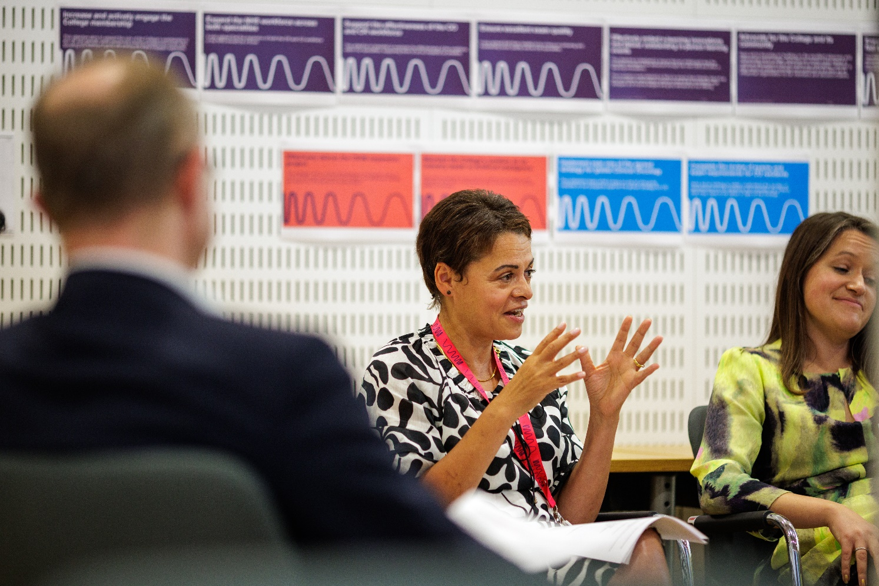
04 | Support and benefits of the role

Support provided to the role
The RCR will offer you support, ensuring that you are equipped to fulfil your role.
This includes:
- RCR's Contributor Officer, providing high-level support for all Contributors,
- the Contributor Code of Conduct and Contributor Handbook, which provide reassurance around our expectations of conduct and personal integrity.
You will be provided with the contact details of your RCR staff contact, who will provide support relevant to your role.

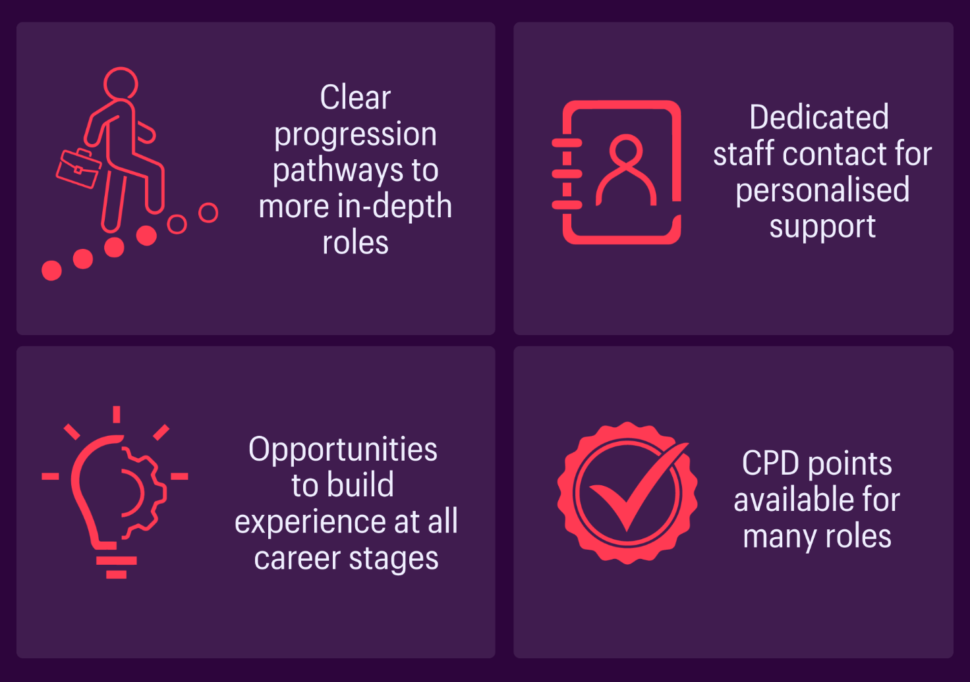
Benefits of the role
05 | Application process

How to apply
If this opportunity interests you, please submit an application via the following form: https://form.asana.com/?k=ObxUB8hMO68evahGdeaKDw&d=602151426521399.
You will be asked about your interests, to provide a short description of your experience and/or interest in contributing to educational initiatives in your area of specialty (max. 150 words), and to upload a short CV.
Applications are welcome from radiology and oncology professional based both within and outside the UK.
If you have any questions, please contact rcrlearning@rcr.ac.uk.

Our commitment to Equality, Diversity, and Inclusion
We are committed to actively fostering an inclusive culture at the RCR. We uphold a commitment to building a Contributor group that reflects the diversity of our global community, and therefore we actively welcome applications from individuals from under-represented groups and diverse backgrounds. We are also dedicated to making reasonable adjustments, for example, offering documents in alternative formats to accommodate neurodiversity. If you would like to discuss this further, please contact the Contributor Officer: contributors@rcr.ac.uk

Important information for Contributors
- We encourage you to explore the Contributor Code of Conduct and Contributor Handbook.
- We request that all applicants complete our EDI Monitoring Form. The information you provide anonymously will help us to understand how our Contributor group represents a diverse range of experience, views and backgrounds. Please complete the form by clicking this link: EDI Monitoring Form for Applicants to Contributor Roles
- All data will be handled in accordance with our data protection policy and membership privacy notice.
- Please note that you may be required to complete a ‘Declaration of conflict of interest’ form.
- For more general queries about the role of an RCR Contributor, please email contributors@rcr.ac.uk


“It’s a great network of colleagues and individuals who share similar interests in education and training.”
“One of the best things I do! Great group of colleagues.”
“An opportunity to work with some inspirational individuals & learn a lot about our specialty.”
“I found it interesting, personally developmental and hugely collaborative.”


The Royal College of Radiologists 63 Lincoln’s Inn Fields
London, WC2A 3JW, UK
The Royal College of Radiologists
is a Charity registered with the
Charity Commission No 211540.

© The Royal College of Radiologists, October 2025.

