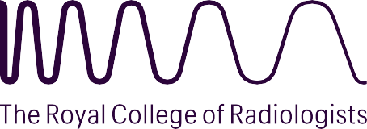

# 2026 DR KAROL SICHER CANCER RESEARCH FELLOWSHIP

Applications are invited for a research fellowship of up to £7000, funded by a generous grant from the estate of the late **Dr Karol Sicher.** The Fellowship is open to Members and Fellows of the Royal College of Radiologists holding a clinical appointment of any grade in the United Kingdom. The Fellowship is intended for a period of study in support of research, in any aspect of cancer diagnosis, assessment or management for up to three months (from April onwards during 2026) in the United Kingdom or abroad. The purpose is to learn a research technique that could be utilised in the applicant’s own department.

At the end of the Fellowship, the successful candidate will be required to send a report to the Royal College of Radiologists.

Due note will be taken of other sources of funding obtained by applicants.

# Applications should comprise

* A completed application form

The application form must be completed electronically and submitted by email only. The application form requires:

* + A detailed account of the proposed project including title, purpose, timing, plan of investigation, methods and techniques of study
  + Details of any co-applicants
  + A budget plan
  + Details of two referees, both of which should be consultant clinical radiologists or clinical oncologists as relevant
* A brief curriculum vitae comprising of 2 pages maximum. This should NOT include a photograph of the applicant
* Letter(s) of support from the project supervisor(s) at the centre(s) at which the project is to be undertaken

# Application and Assessment Procedure

* Applications should be sent electronically to [research@rcr.ac.uk](mailto:research@rcr.ac.uk) at the Royal College of Radiologists to arrive **not later than 5pm on Friday 14 November 2025.**
* An assessment panel nominated by the Royal College of Radiologists will consider applications. The decision of the assessment panel is final and binding.
* Shortlisted candidates may be interviewed by the assessment panel after the closing date.
* Applicants will be informed of the outcome of their applications in early March 2026.