Appointed member of the Standing Northern Ireland Committee

Contributor candidate pack
01 | Welcome


It’s a pleasure to welcome you as you explore the opportunity to contribute to the work of the Royal College of Radiologists. I’m delighted that you’re considering joining our committed community of professionals who contribute their time, skills and experience to support our work.
At the RCR, colleagues like you are absolutely vital to the work we do. You play a key role in helping us support excellence in medical imaging, interventional radiology and cancer treatment - both now and in the future. In contributing your time, expertise, and perspective, your involvement strengthens our impact and supports the delivery of safe, high-quality patient care, which sits at the heart of everything we do.
As a Contributor, you will help us deliver the College’s strategic priorities, including providing excellent standards and guidance for the workforce, delivery of high-quality professional learning, and being recognised as the experts in our fields. Your insight and involvement help ensure that our specialties continue to grow in both strength and influence.
Many of our Contributors have told us they choose to give their time because they want to make a real difference to our specialties. And by getting involved, they’ve also found opportunities to build lasting professional networks and stay connected with peers across the UK and beyond. The same will be true for you.
We’re proud to be a college that works in partnership with its members. Our Contributors bring energy, ideas, and commitment that shape our work and our future - and we are stronger because of it.
I look forward to the opportunity to work with you.

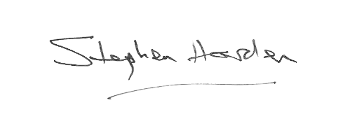
With warm wishes,

Dr Stephen Harden
President of The Royal College of Radiologists

02 | Role Summary

Role title: | Appointed member of the Standing Northern Ireland Committee
Time Commitment: | Term of Office is three years, and may exceptionally be extended by up to three years
Location: | Remote
Closing date for applications: | 6th March 2026

Why this role exists
The Standing Northern Ireland Committee (SNIC) provides advice and guidance to the Trustee Board on the issues concerning Clinical Radiologists and Clinical Oncologists specifically within Northern Ireland. It is also the means by which the Royal College of Radiologists (RCR) can provide tailored support to its members in Northern Ireland.

Your impact
The SNIC has four overarching purposes:
- To provide advice and guidance to the Trustee Board on issues concerning Clinical Radiologists and Clinical Oncologists specifically within Northern Ireland
- To provide a means for the RCR to provide support to its members and the specialties in Northern Ireland
- To give voice to the RCR in Northern Ireland
- To inform a four-nations’ view on College work

Each appointed member has the responsibility of ensuring that the views and concerns of the clinical oncologists or clinical radiologists in their regions are relayed to the Standing Northern Ireland Committee, which in turn feeds back to RCR.

03 | Key responsibilities and requirements

A Fellow or member in good standing, applying for appointment to the Committee must have the knowledge and experience of Clinical Radiology/Clinical Oncology and be able to demonstrate an interest in and experience of at least some of the following attributes and areas of practice:

Knowledge, qualifications and experience | Essential (E) or Desirable (D)
Hold a current licence to practise in the UK, practising in Northern Ireland  and have the majority of their sessions within the relevant region | E
Experience of working in one or more of the following: District General Hospital, Regional Centre, or Teaching Hospital | E
Experience of training, management, or governance within Clinical Radiology / Clinical Oncology | E
Skills and abilities
A commitment to abide by the Contributor Code of Conduct. | E
Good interpersonal skills and a proven ability to work in a Committee setting | E

Other Requirements
All RCR board and committee members are expected to demonstrate adherence to the College values & strategy. All board and committee members will be required to declare any conflicts at the beginning of every meeting in accordance with the conflicts of interest policy.

04 | Commitment and conditions

Contributors at the RCR play a vital role in supporting the College’s initiatives and driving its progress. Although our Contributor positions are undertaken on a voluntary basis, each role has optimal impact when Contributors dedicate sufficient time to fulfilling the responsibilities entrusted to them.
The Term of Office of appointed members will be three years and may exceptionally be extended by up to three years by mutual agreement of the respective member, the Chair and RCR Vice-Presidents.

The main responsibilities are to attend three Standing Northern Ireland Committee meetings each year, each lasting between one and three hours. The College has adapted to remote meetings, and these are held generally in January and September/October with one face-to-face meeting per year in May/June. In addition, you will need to allow time to read papers in advance and potentially resolve issues by remote discussion between meetings. There may also be an opportunity to get involved in a short-term working party or project group, reporting to the Committee, from time to time.
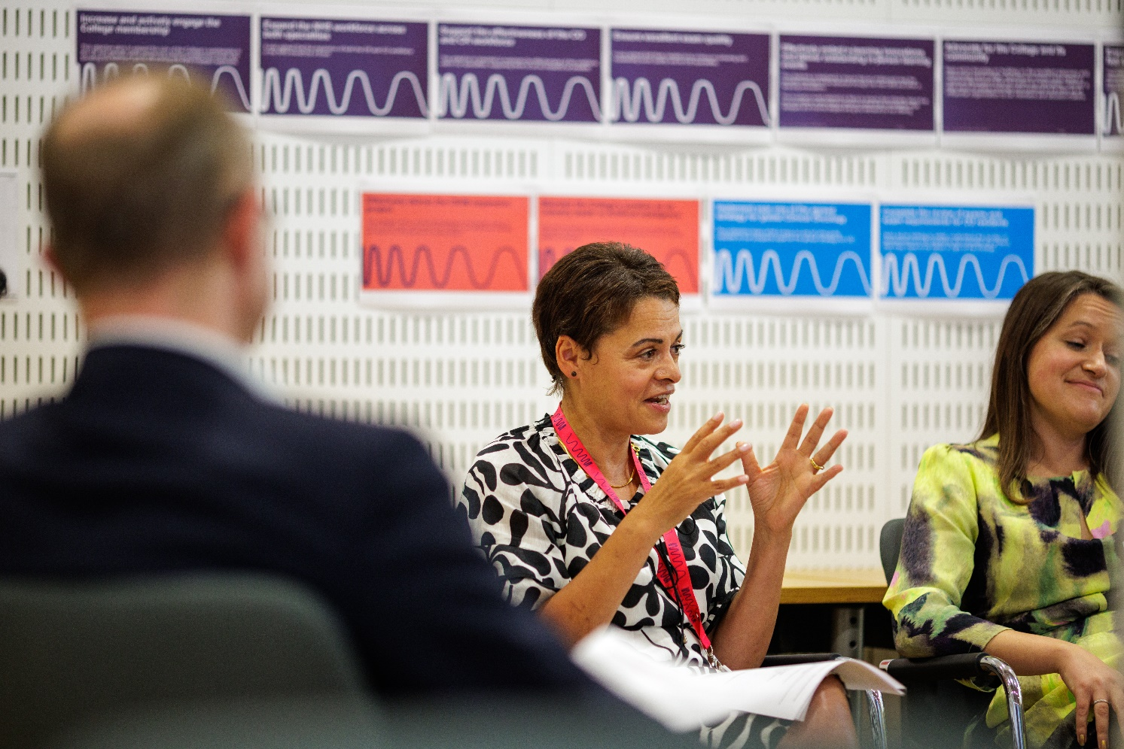
05 | Support and benefits of the role

Support provided to the role
The RCR will offer you strong support, ensuring that you are informed, feel valued, and are equipped to fulfil your role.
This includes:
- information and administrative support provided by an RCR staff contact
- regular engagement opportunities with RCR staff and fellow Contributors,
- RCR's Contributor Officer, providing high-level support for all Contributors,
- the opportunity to attend induction sessions, providing you with all relevant information to fulfil your role effectively,
- the Contributor Code of Conduct and Contributor Handbook, which provide reassurance around our expectations of conduct and personal integrity.

Benefits of the role
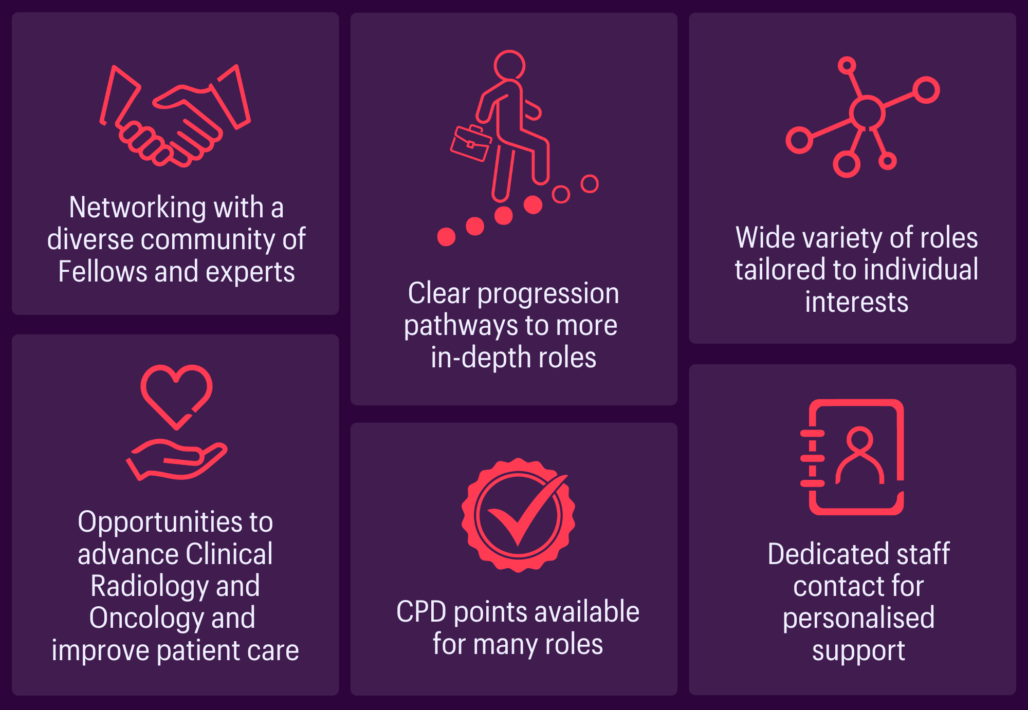

06 | Application process

How to apply
Applicants are asked to submit a short CV and a brief statement outlining their relevant experience and interests, and how these meet the attributes listed above.

Please submit your application to the Governance Assistant by 5pm on Friday 6th March 2026.

Applications will be assessed by the Chair and Vice-Chair of the Standing Northern Ireland Committee.

Our commitment to Equality, Diversity, and Inclusion
We are committed to actively fostering an inclusive culture at the RCR. We uphold a commitment to building a Contributor group that reflects the diversity of our global community, and therefore we actively welcome applications from individuals from under-represented groups and diverse backgrounds. We are also dedicated to making reasonable adjustments, for example, offering documents in alternative formats to accommodate neurodiversity. If you would like to discuss this further, please contact the Contributor Officer: contributors@rcr.ac.uk

Important information for Contributors
- We encourage you to explore the Contributor Code of Conduct and Contributor Handbook.
- We request that all applicants complete our EDI Monitoring Form. The information you provide anonymously will help us to understand how our Contributor group represents a diverse range of experience, views and backgrounds. Please complete the form by clicking this link: EDI Monitoring Form for Applicants to Contributor Roles
- All data will be handled in accordance with our data protection policy and membership privacy notice.
- Please note that you may be required to complete a ‘Declaration of conflict of interest’ form.
- For more general queries about the role of an RCR Contributor, please email contributors@rcr.ac.uk


“It’s a great network of colleagues and individuals who share similar interests in education and training.”
“One of the best things I do! Great group of colleagues.”
“An opportunity to work with some inspirational individuals & learn a lot about our specialty.”
“I found it interesting, personally developmental and hugely collaborative.”

The Royal College of Radiologists 63 Lincoln’s Inn Fields
London, WC2A 3JW, UK
The Royal College of Radiologists
is a Charity registered with the
Charity Commission No 211540.

© The Royal College of Radiologists, October 2025.



