Fairer Training Fellow Reverse Mentoring

Contributor candidate pack
01 | Welcome


It’s a pleasure to welcome you as you explore the opportunity to contribute to the work of the Royal College of Radiologists. I’m delighted that you’re considering joining our committed community of professionals who contribute their time, skills and experience to support our work.
At the RCR, colleagues like you are absolutely vital to the work we do. You play a key role in helping us support excellence in medical imaging, interventional radiology and cancer treatment - both now and in the future. In contributing your time, expertise, and perspective, your involvement strengthens our impact and supports the delivery of safe, high-quality patient care, which sits at the heart of everything we do.
As a Contributor, you will help us deliver the College’s strategic priorities, including providing excellent standards and guidance for the workforce, delivery of high-quality professional learning, and being recognised as the experts in our fields. Your insight and involvement help ensure that our specialties continue to grow in both strength and influence.
Many of our Contributors have told us they choose to give their time because they want to make a real difference to our specialties. And by getting involved, they’ve also found opportunities to build lasting professional networks and stay connected with peers across the UK and beyond. The same will be true for you.
We’re proud to be a college that works in partnership with its members. Our Contributors bring energy, ideas, and commitment that shape our work and our future - and we are stronger because of it.
I look forward to the opportunity to work with you.


With warm wishes,

Dr Stephen Harden
President of The Royal College of Radiologists

02 | Role Summary

Role title: | Fairer Training Fellow – Reverse Mentoring  1 x clinical radiology  1 x clinical oncology
Time Commitment: | 18 months, with possible extension
Location: | Hybrid – with some attendance at Royal College of Radiologists in London
Closing date for applications: | Friday 22nd May

Background
The Reverse Mentoring programme was established in 2023 by the first cohort of Fairer Training fellows. Due to its success the College took on this initiative as business as usual; this became an annual programme within the College’s wider mentoring offer.

Impact
Are you passionate about ensuring enabling equity, inclusion and diversity in your speciality? We’re looking for two residents to join us in supporting the next cohort of reverse mentoring programme.
The RCR has a strong commitment to supporting members and Fellows at all stages of their professional careers. Mentoring can play a key part in this support. Reverse mentoring, where the traditional roles are flipped has been evidenced to cut through hierarchy, bridge generational and cultural gaps and encourage innovation. Reverse mentoring can strengthen communication, boost collaboration and ensure that leadership is connected to the reality of the workforce and patient communities.
This role is an opportunity to lead on the RCR’s reverse mentoring project and contribute directly to the RCR’s Equality, Diversity and Inclusion ambitions. The role involves preparing documentation to support the cohort, recruitment, lead and support of mentors and mentees and evaluation of the project.
Expectations
We would welcome the new Fellows taking ownership of these recommendations and bringing fresh thinking to shape the next iteration of the scheme. In particular, we encourage focused on areas of setting shared expectations for mentors and mentees, cultural awareness, neuro-inclusion, and understanding and addressing structural inequalities.
- Work alongside another Fairer Training Fellow to lead the next cohort of reverse mentoring
- Lead recruitment process for mentees and mentors
- Provide support to mentees and mentors throughout the process
- Lead welcome induction meeting

Eligibility
Applicants must:
- Be member or Fellow of RCR
- Be a resident doctor in Clinical Radiology Grade ST3+ (third year of training) Clinical Oncology Grade ST5+ (third year of training)
- Demonstrates a clear interest in developing their leadership profile through a national role.

Reporting and Key Relationships
Reports to:
- Lead Mentoring Advisor
Works closely with:
- Officers of the RCR, in particular the Medical Directors for Education and Training (MDETs), and Medical Directors for Professional Practice (MDPPs) where required
- Chairs of the Radiology Resident Doctors Forum (RRDF)
- Chairs of the Oncology Registrars Forum (ORF)
- Professional Networks Team

03 | Key responsibilities and requirements

Key Responsibilities
Orientation
- Understand how previous cohorts of the reverse mentoring programme have run
- Analyse data and reports from previous cohorts to identify gaps in existing reverse mentoring programme and areas for improvement
Project management
- Redesign key parts of the reverse mentoring programme to ensure it is fit for purpose
- Develop guidance for participants that supports meaningful conversations.
- Integrate learning from similar programmes and explore new ideas.
Stakeholder engagement
- Build relationships with:
  - Lead Mentoring Advisor to provide appropriate support
  - Radiology Resident Doctors Forum
  - Oncology Registrars Forum
  - Medical Directors for Education and Training
  - Medical Directors for Professional Practice
  - Professional Networks Team
- Seek input from Officers and RCR members and Fellows
- Work with RCR Marketing and Digital team to promote the project to recruit mentees and mentors
- Act as an ambassador for mentoring across the RCR and across professional networks
Delivery
- Plan, launch and support a high-quality experience for the next cohort of mentees and mentors
- Recruit, support and retain sufficient mentees and mentors to ensure a suitable range of experience and speciality
- Plan, lead and facilitate meetings with new cohort- including welcome meeting, check in review meeting and evaluation
- Present at relevant boards and committees to promote mentor-mentee recruitment
- Use personal and professional networks to increase engagement and recruitment
- Ensure participants understand the purpose and expectation of involvement
Evaluation
- Gather and evaluate structured feedback from participants
- Identify successes and opportunities for next cohort
- Produce a clear report with clear recommendations and next steps.

Person Specification

Knowledge, qualifications and experience | Essential (E) or Desirable (D)
Understanding of equality, diversity and inclusion (EDI) principles | E
Involvement in quality improvement and or evaluation projects | E
Demonstrable interest in mentoring | D
Leadership experience | D
Experience supporting people with widening participation criteria or underrepresented groups | D
Skills and abilities
Good interpersonal skills and a proven ability to work in a network setting | E
Ability to evaluate information and make practical recommendations through report writing | E
Creativity and willingness to explore new ideas | E
Motivation to develop leadership skills through national role | E
Clear verbal and written communication | E
Teamwork, collaboration and engagement | E
Commitment to abide by the Contributor Code of Conduct. | E
Commitment to fairness, inclusion and improving training experiences | E

04 | Commitment and conditions

Contributors at the RCR play a vital role in supporting the College’s initiatives and driving its progress. Although our Contributor positions are undertaken on a voluntary basis, each role has optimal impact when Contributors dedicate sufficient time to fulfilling the responsibilities entrusted to them.
The role is set at 18 months to allow sufficient time to prepare the launch of the next cohort and to support participants throughout their reverse mentoring journey. Once the mentoring cycle has concluded, there will be time to evaluate feedback, assess whether the project has achieved its intended aims and objectives, and understand the overall impact.

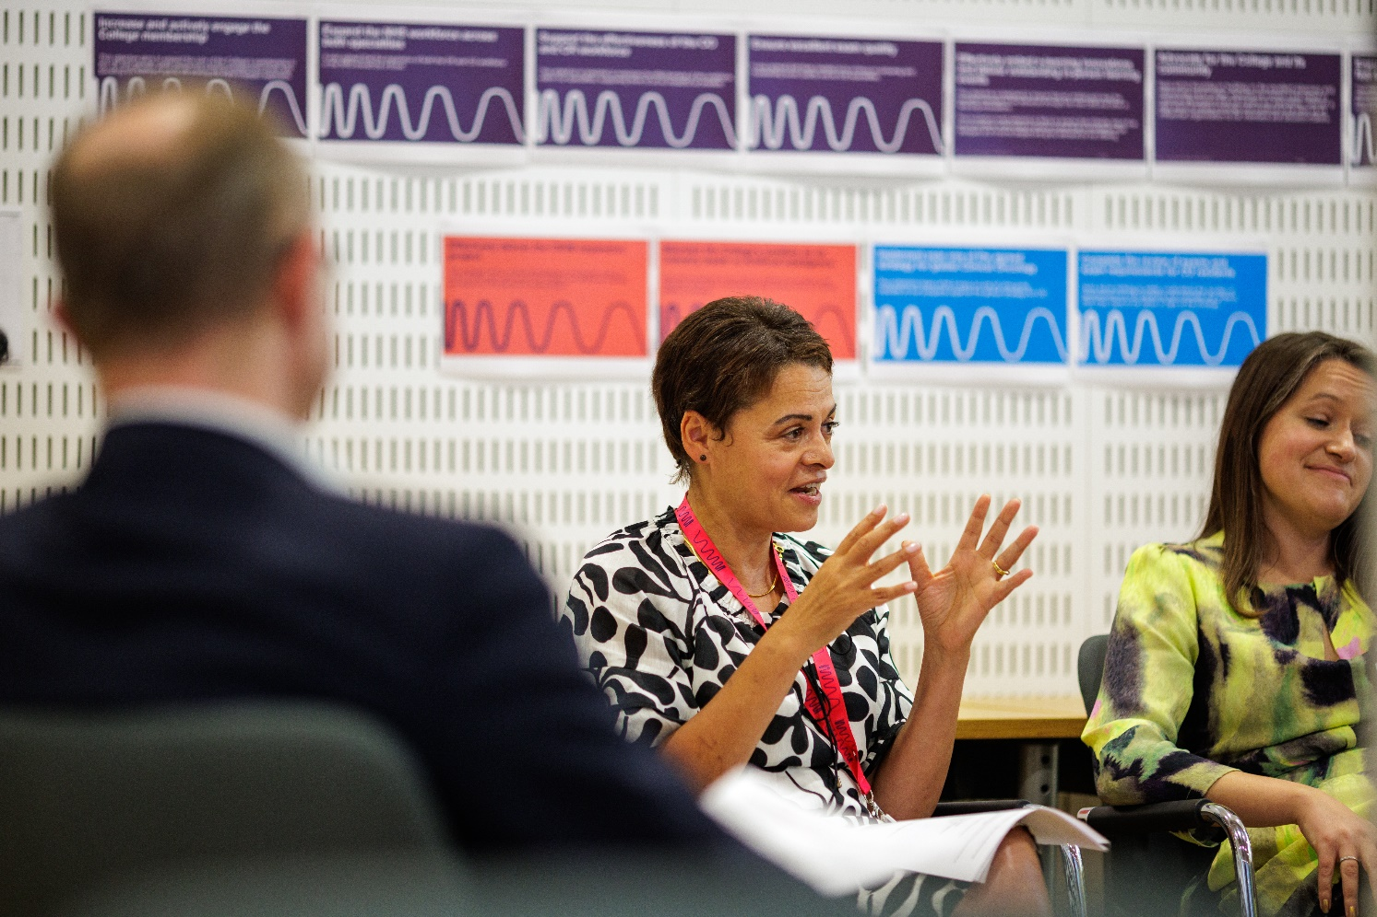
05 | Support and benefits of the role

Support provided to the role
The RCR will offer you strong support, ensuring that you are informed, feel valued, and are equipped to fulfil your role.
This includes:
- information and administrative support provided by Professional Networks team
- supervision and guidance provided by the Lead Mentoring Advisor
- regular engagement opportunities with RCR staff and fellow Contributors,
- RCR's Contributor Officer, providing high-level support for all Contributors,
- the opportunity to attend induction sessions, providing you with all relevant information to fulfil your role effectively,
- the Contributor Code of Conduct and Contributor Handbook, which provide reassurance around our expectations of conduct and personal integrity.

This role would help residents demonstrate progress towards curriculum capabilities- CiP3 and 6 for CR and CiP 3 and 4 for CO.
Benefits of the role

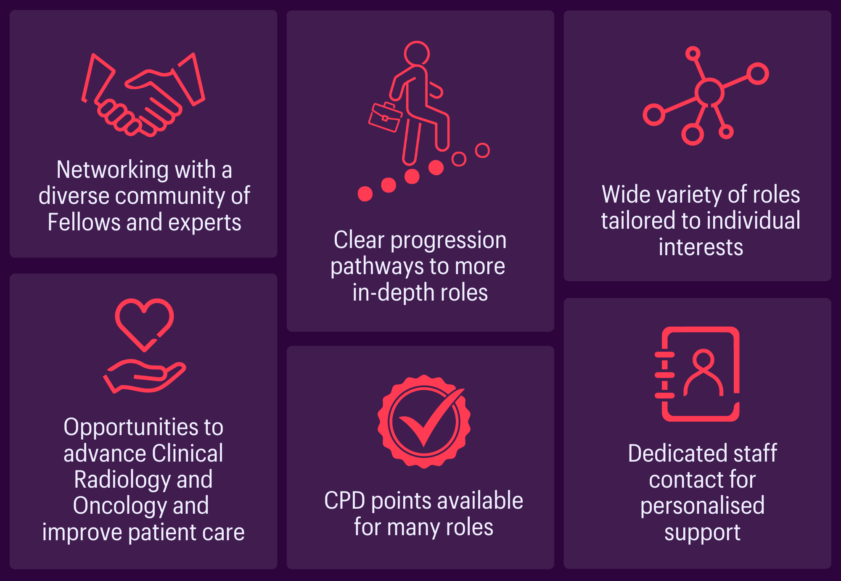
Leadership skills in a national role

 Leadership skills in a national role
06 | Application process

How to apply
Please submit a CV and brief covering letter to mentoring@rcr.ac.uk by Friday 22nd May.

Our commitment to Equality, Diversity, and Inclusion
We are committed to actively fostering an inclusive culture at the RCR. We uphold a commitment to building a Contributor group that reflects the diversity of our global community, and therefore we actively welcome applications from individuals from under-represented groups and diverse backgrounds. We are also dedicated to making reasonable adjustments, for example, offering documents in alternative formats to accommodate neurodiversity. If you would like to discuss this further, please contact the Contributor Officer: contributors@rcr.ac.uk

Important information for Contributors
- We encourage you to explore the Contributor Code of Conduct and Contributor Handbook.
- We request that all applicants complete our EDI Monitoring Form. The information you provide anonymously will help us to understand how our Contributor group represents a diverse range of experience, views and backgrounds. Please complete the form by clicking this link: EDI Monitoring Form for Applicants to Contributor Roles
- All data will be handled in accordance with our data protection policy and membership privacy notice.
- Please note that you may be required to complete a ‘Declaration of conflict of interest’ form.
- For more general queries about the role of an RCR Contributor, please email contributors@rcr.ac.uk


“It’s a great network of colleagues and individuals who share similar interests in education and training.”
“One of the best things I do! Great group of colleagues.”
“An opportunity to work with some inspirational individuals & learn a lot about our specialty.”
“I found it interesting, personally developmental and hugely collaborative.”

The Royal College of Radiologists 63 Lincoln’s Inn Fields
London, WC2A 3JW, UK
The Royal College of Radiologists
is a Charity registered with the
Charity Commission No 211540.

© The Royal College of Radiologists, October 2025.



