Lead Mentoring Advisor

Contributor candidate pack
01 | Welcome


It’s a pleasure to welcome you as you explore the opportunity to contribute to the work of the Royal College of Radiologists. I’m delighted that you’re considering joining our committed community of professionals who contribute their time, skills and experience to support our work.
At the RCR, colleagues like you are absolutely vital to the work we do. You play a key role in helping us support excellence in medical imaging, interventional radiology and cancer treatment - both now and in the future. In contributing your time, expertise, and perspective, your involvement strengthens our impact and supports the delivery of safe, high-quality patient care, which sits at the heart of everything we do.
As a Contributor, you will help us deliver the College’s strategic priorities, including providing excellent standards and guidance for the workforce, delivery of high-quality professional learning, and being recognised as the experts in our fields. Your insight and involvement help ensure that our specialties continue to grow in both strength and influence.
Many of our Contributors have told us they choose to give their time because they want to make a real difference to our specialties. And by getting involved, they’ve also found opportunities to build lasting professional networks and stay connected with peers across the UK and beyond. The same will be true for you.
We’re proud to be a college that works in partnership with its members. Our Contributors bring energy, ideas, and commitment that shape our work and our future - and we are stronger because of it.
I look forward to the opportunity to work with you.


With warm wishes,

Dr Stephen Harden
President of The Royal College of Radiologists

02 | Role Summary

Role title: | Lead mentoring advisor
Time Commitment: | 3 years
Location: | Remote, UK based  We anticipate this role to have a number of speaking opportunities throughout the year- namely New Consultants Day (typically at the start of May) and RadReach welcome day (typically end of June)
Closing date for applications: | Friday 22nd May 2026

Background

In recent years, the RCR’s mentoring portfolio has expanded considerably, supported by the procurement of an online mentoring platform. The College now runs 4 programmes: RCR mentoring, RadReach, reverse mentoring, BSIR mentoring with another two in active development.
Due to the active development and growing interest in this area a need has been identified for doctor-led oversight and leadership. We are seeking a designated expert contributor to guide the coherence and development of our mentoring offer, future delivery models and cross-scheme alignment.
Purpose of the role
To provide expert leadership, quality oversight, and strategic advice for the development, delivery, and evaluation of all RCR mentoring schemes—ensuring a high-quality, inclusive, and impactful mentoring experience for all users across the mentoring portfolio.
The Lead Mentoring Advisor will be supported by the Professional Networks team who administer the operational delivery of the mentoring offer.
Our mentoring programme is open to members and Fellows across both of the RCR’s Faculties – clinical oncology and clinical radiology. We would welcome a Lead Mentoring Advisor who is comfortable working across both specialties, but will consider appointing two Advisors, one from each Faculty, dependent upon the applications received.

Expectations
The role will focus on the following:
- Provide coherent oversight across programmes, considering how the RCR can facilitate a consistently high-quality mentoring experience (and how we can measure that more readily), reducing duplication, and providing improved curation of mentoring guidance and resources.
- Strengthen the mentor recruitment narrative
- Provide a credible clinical voice in outreach and engagement activities.
- Provide support and mentorship to any future Fairer Training Fellows who may be recruited to support specific schemes (e.g. Reverse Mentoring).
- Identify, test, evaluate and scale future alternative delivery options to ensure the offer remains relevant and dynamic.

Reporting and Key Relationships
Supported by: The Professional Networks Manager and team
Supports:
- Fairer Training Fellows x 2
Works closely with:
- Officers of the RCR, in particular the Medical Directors for Professional Practice (MDPPs)
- Chairs of the Radiology Resident Doctors Forum (RRDF)
- Chairs of the Oncology Registrars Forum (ORF)

03 | Key responsibilities and requirements

Key Responsibilities
Leadership and developmental oversight
- Work towards the long- term strategic goals of mentoring in agreement with RCR staff members and Officers
- Provide expert advice on the strategic direction of the RCR mentoring portfolio
- Ensure coherence across schemes with differing aims, audiences, recruitment cycles, and delivery models
- Provide recommendations for scaling or adapting new delivery options to meet emerging member needs
- Write reports to RCR boards and committees as required on progress and future plans for mentoring
Quality assurance
- Work with College staff to ensure the facilitation of a consistently high-quality mentoring experience
- Support the development of a more robust evidence base for decision-making and impact assessment.
Profile, impact and engagement
- Act as an ambassador for mentoring within the RCR, supporting outreach and engagement across member networks
- Champion the work of all mentoring programmes at senior board and committee level across the RCR.
- Support recruitment and retention of mentors and mentees across all schemes
- Support communication campaigns and represent mentoring at relevant events and forums
- Advise on strategic initiatives affecting mentoring, including equality, diversity and inclusion priorities
Supporting the Fairer Training Fellows
- Support with recruitment of Fairer Training Fellows who lead on the reverse mentoring programme ensuring appropriate experience and representation
- Mentor and coach Fairer Training Fellows
- Champion the work of the Fellows’ mentoring initiatives across the RCR

Knowledge, qualifications and experience | Essential (E) or Desirable (D)
Be a Fellow of the RCR currently practising clinical radiology or clinical oncology in the UK | E
Demonstrable leadership experience | E
Understanding of equality, diversity and inclusion (EDI) principles | E
Demonstrable interest in mentoring | E
Experience supporting people from a widening participation background or from otherwise underrepresented groups | D
Skills and abilities
A commitment to abide by the Contributor Code of Conduct. | E
Good interpersonal skills | E
Ability to inspire engagement and participation from peers and stakeholder
Ability to evaluate information and use it to make practical recommendations | E
Clear verbal and written communication | E

04 | Commitment and conditions

Contributors at the RCR play an essential role in supporting the College’s strategic initiatives and shaping the direction of the College. Although our Contributor positions are undertaken on a voluntary basis, each role has optimal impact when Contributors dedicate sufficient time to fulfilling the responsibilities entrusted to them.
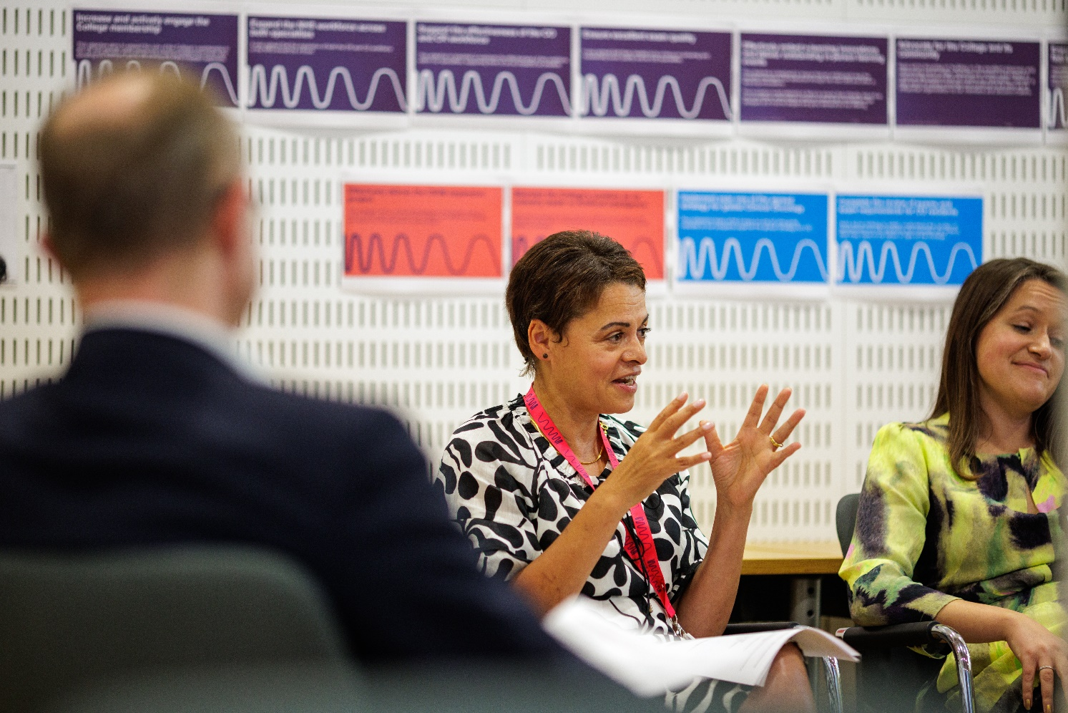
The time commitment for this role is expected to be 1-2 hours a week on average. The role will involve some variation across the year, with occasional periods of increased activity during mentor/mentee recruitment cycles, matching and any other key mentoring programme events.

05 | Support and benefits of the role

Support provided to the role
The RCR will offer you strong support, ensuring that you are informed, feel valued, and are equipped to fulfil your role.
This includes:
- information and administrative support provided by Professional Networks team
- regular engagement opportunities with RCR staff and fellow Contributors,
- RCR's Contributor Officer, providing high-level support for all Contributors,
- the opportunity to attend induction sessions, providing you with all relevant information to fulfil your role effectively,
- the Contributor Code of Conduct and Contributor Handbook, which provide reassurance around our expectations of conduct and personal integrity.
Benefits of the role
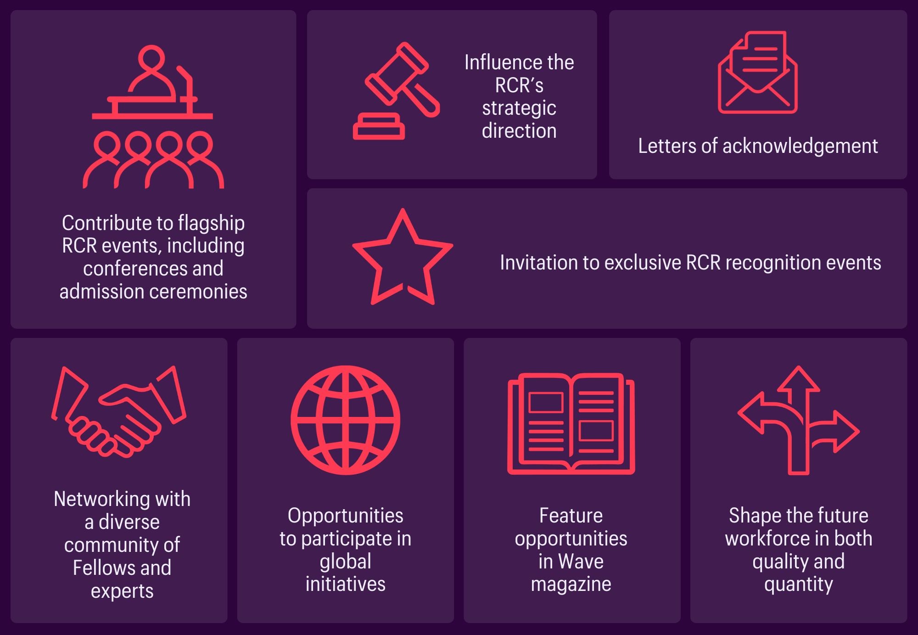

06 | Application process

How to apply

Please submit a CV and brief covering letter to mentoring@rcr.ac.uk by Friday 22nd May 2026.

Our commitment to Equality, Diversity, and Inclusion
We are committed to actively fostering an inclusive culture at the RCR. We uphold a commitment to building a Contributor group that reflects the diversity of our global community, and therefore we actively welcome applications from individuals from under-represented groups and diverse backgrounds. We are also dedicated to making reasonable adjustments, for example, offering documents in alternative formats to accommodate neurodiversity. If you would like to discuss this further, please contact the Contributor Officer: contributors@rcr.ac.uk

Important information for Contributors
We encourage you to explore the Contributor Code of Conduct and Contributor Handbook.
We request that all applicants complete our EDI Monitoring Form. The information you provide anonymously will help us to understand how our Contributor group represents a diverse range of experience, views and backgrounds. Please complete the form by clicking this link: EDI Monitoring Form for Applicants to Contributor Roles
All data will be handled in accordance with our data protection policy and membership privacy notice.
Please note that you may be required to complete a ‘Declaration of conflict of interest’ form.
For more general queries about the role of an RCR Contributor, please email contributors@rcr.ac.uk


“It’s a great network of colleagues and individuals who share similar interests in education and training.”
“One of the best things I do! Great group of colleagues.”
“An opportunity to work with some inspirational individuals & learn a lot about our specialty.”
“I found it interesting, personally developmental and hugely collaborative.”

The Royal College of Radiologists 63 Lincoln’s Inn Fields
London, WC2A 3JW, UK
The Royal College of Radiologists
is a Charity registered with the
Charity Commission No 211540.

© The Royal College of Radiologists, October 2025.



