Clinical Oncology Undergraduate Committee member

Contributor candidate pack
01 | Welcome


It’s a pleasure to welcome you as you explore the opportunity to contribute to the work of the Royal College of Radiologists. I’m delighted that you’re considering joining our committed community of professionals who contribute their time, skills and experience to support our work.
At the RCR, colleagues like you are absolutely vital to the work we do. You play a key role in helping us support excellence in medical imaging, interventional radiology and cancer treatment - both now and in the future. In contributing your time, expertise, and perspective, your involvement strengthens our impact and supports the delivery of safe, high-quality patient care, which sits at the heart of everything we do.
As a Contributor, you will help us deliver the College’s strategic priorities, including providing excellent standards and guidance for the workforce, delivery of high-quality professional learning, and being recognised as the experts in our fields. Your insight and involvement help ensure that our specialties continue to grow in both strength and influence.
Many of our Contributors have told us they choose to give their time because they want to make a real difference to our specialties. And by getting involved, they’ve also found opportunities to build lasting professional networks and stay connected with peers across the UK and beyond. The same will be true for you.
We’re proud to be a college that works in partnership with its members. Our Contributors bring energy, ideas, and commitment that shape our work and our future - and we are stronger because of it.
I look forward to the opportunity to work with you.


With warm wishes,

Dr Stephen Harden
President of The Royal College of Radiologists

02 | Role Summary

Role title: | Clinical Oncology Undergraduate Committee member
Time Commitment: | Three virtual meetings annually
Location: | Remote
Closing date for applications: | Tuesday 7th April 2026

Why this role exists
The Clinical Oncology Undergraduate Committee aims to enhance awareness among undergraduates, Foundation Year (FY) doctors, and Internal Medicine Training (IMT) residents regarding the pivotal role of oncology within healthcare, whilst also promoting clinical oncology (CO) as a rewarding and attractive career path.

The committee member role is essential in inspiring medical students, FY doctors, and IMT residents to explore and recognise the breadth of career opportunities within oncology, with an emphasis on CO training as a dynamic, innovative, and highly rewarding specialty. Committee members will promote the importance of oncological knowledge from the earliest stages of training, supporting learners as they develop their clinical interests and career aspirations.

Your impact
Committee Members play a pivotal role in elevating the profile of CO as a specialty, inspiring the next generation of doctors to consider a career in this field. Through proactive engagement and advocacy, they will directly contribute to strengthening recruitment into the specialty. In doing so, they will have a lasting and meaningful impact on the future of cancer care, supporting continued innovation, excellence, and improved outcomes for patients.

The Committee reports to the Medical Director, Education and Training (MDET), Clinical Oncology and the Specialty Training Board (STB).

03 | Key responsibilities and requirements

Members will be required to take a leading role in promoting the specialty to undergraduates, FY doctors, and IMT residents which may include, but will not be limited to, the following:
- Promoting the RCR undergraduate non-surgical oncology curriculum.
- Identifying, promoting, and supporting undergraduate oncological societies and encouraging their creation in all medical schools.
- Facilitating networking opportunities for societies to communicate ideas and resources.
- Identifying, creating and/or commissioning oncology-focused undergraduate teaching resources.
- Activities to promote CO as a career option, including but not limited to the annual Oncology Careers Day and recruitment webinars.
- Judging of applications for awards and bursaries aimed at promoting CO to undergraduates, FY, and IMT residents.

Knowledge, qualifications and experience | Essential (E) or Desirable (D)
Demonstrable interest in oncology/clinical oncology | E
Experience in education | E
Actively involved with undergraduate, foundation year and/or Internal Medicine Training education | E
Experience in leadership | D
Skills and abilities
Clear verbal and written communication | E
Teamwork, collaboration and engagement | E
A commitment to abide by the Contributor Code of Conduct. | E
Strategic thinking | D

Other Requirements
All RCR board and committee members are expected to demonstrate adherence to the College values & strategy. All board and committee members will be required to declare any conflicts at the beginning of every meeting in accordance with the conflicts of interest policy.
- All members should be currently living in the UK.
- Consultant members should be Fellows of the RCR in good standing and in active clinical practice.
- CO resident members should be Members or Fellows of the RCR in good standing, and either currently in UK specialty training or on approved out of programme activity.
- Undergraduate members should be in their third year or above of medical school.
- FY and IMT residents should ideally be in the first year of their training programme or on approved out of programme activity.

04 | Commitment and conditions

Contributors at the RCR play a vital role in supporting the College’s initiatives and driving its progress. Although our Contributor positions are undertaken on a voluntary basis, each role has optimal impact when Contributors dedicate sufficient time to fulfilling the responsibilities entrusted to them.
The committee is expected to meet three times per year, virtually. It is expected that members will carry out the bulk of committee work remotely by email.
- The term of office for consultant and CO resident members will be three years with the option of being re-appointed for one further term of three years.
- The term of office for undergraduates, FY and IMT resident members will be two years or until completion of their FY or IMT training.

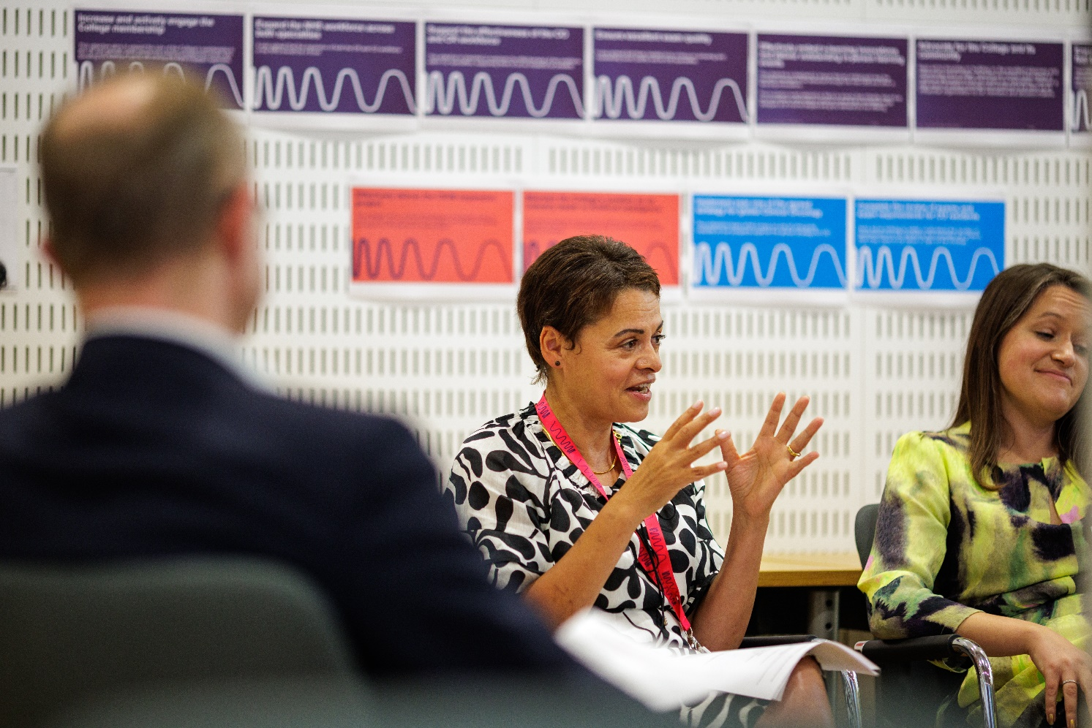
05 | Support and benefits of the role

Support provided to the role
The RCR will offer you strong support, ensuring that you are informed, feel valued, and are equipped to fulfil your role.
This includes:
- information and administrative support provided by an RCR staff contact
- regular engagement opportunities with RCR staff and fellow Contributors,
- RCR's Contributor Officer, providing high-level support for all Contributors,
- the opportunity to attend induction sessions, providing you with all relevant information to fulfil your role effectively,
- the Contributor Code of Conduct and Contributor Handbook, which provide reassurance around our expectations of conduct and personal integrity.

Benefits of the role
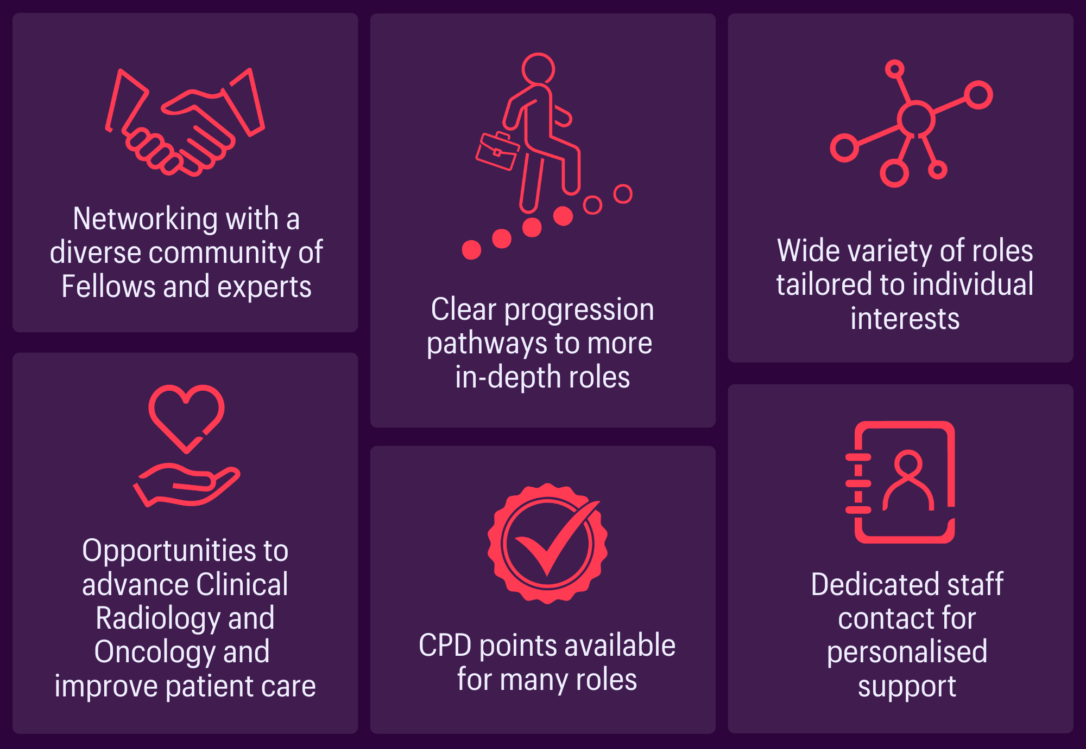

06 | Application process

How to apply
Applicants are required to send a short CV along with the completed application form to workforce@rcr.ac.uk by 5:00pm on Tuesday 7th of April 2026.
Applications will be assessed by the Chair of the CO Undergraduate Committee and the Medical Director Education and Training of the Faculty. It will be ensured that no member of the selection panel has a conflict of interest with any applicant. It is not anticipated that it will be necessary to hold interviews.

Our commitment to Equality, Diversity, and Inclusion
We are committed to actively fostering an inclusive culture at the RCR. We uphold a commitment to building a Contributor group that reflects the diversity of our global community, and therefore we actively welcome applications from individuals from under-represented groups and diverse backgrounds. We are also dedicated to making reasonable adjustments, for example, offering documents in alternative formats to accommodate neurodiversity. If you would like to discuss this further, please contact the Contributor Officer: contributors@rcr.ac.uk

Important information for Contributors
- We encourage you to explore the Contributor Code of Conduct and Contributor Handbook.
- We request that all applicants complete our EDI Monitoring Form. The information you provide anonymously will help us to understand how our Contributor group represents a diverse range of experience, views and backgrounds.
- All data will be handled in accordance with our data protection policy and membership privacy notice.
- Please note that you may be required to complete a ‘Declaration of interest’ form.
- For more general queries about the role of an RCR Contributor, please email contributors@rcr.ac.uk


“It’s a great network of colleagues and individuals who share similar interests in education and training.”
“One of the best things I do! Great group of colleagues.”
“An opportunity to work with some inspirational individuals & learn a lot about our specialty.”
“I found it interesting, personally developmental and hugely collaborative.”

The Royal College of Radiologists 63 Lincoln’s Inn Fields
London, WC2A 3JW, UK
The Royal College of Radiologists
is a Charity registered with the
Charity Commission No 211540.

© The Royal College of Radiologists, October 2025.



