Audit title
MRI protocol in patients with endometrial cancer

Descriptor
Assessment of compliance with best practise guidelines for MR imaging in histologically proven endometrial carcinoma, taking into consideration both RCR recommendations and ESUR guidelines.

Background
In women in the UK, uterine cancer is the 4th most common cancer, with around 9,700 new cases every year (2016-2018). MRI is the optimum modality for preoperative assessment and treatment planning by accurately predicting depth of myometrial invasion, cervical stromal invasion and lymph node involvement. Tumor grade and lymph node metastases correlate with depth of myometrial invasion which is the most important morphologic prognostic factor. Myometrial invasion is best assessed by a combination of T2 weighted, DWI and dynamic contrast enhanced sequences.

The standard
MRI protocol (as conforming to best practise guidelines in the local setting) for histologically proven endometrial carcinoma/complex atypical hyperplasia includes:

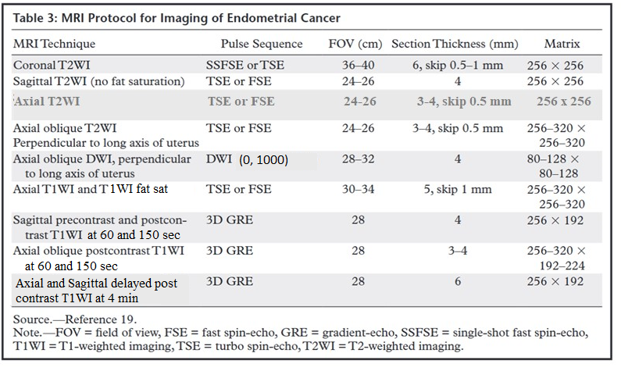

Target
100% of scans to adhere to the above mentioned protocol.

Indicators
% of MRI scans adhering to the above-mentioned protocol.
% of patients who received an antiperistaltic agent.
% of scans where a sequence is omitted.
% of scans where the angles are not satisfactory.
% of scans with inhomogeneous fat suppression, motion or other artefact.

Data items to be collected
Cohort of patients with histologically proven endometrial carcinoma/complex atypical hyperplasia who underwent preoperative MRI.
MRI pelvis protocol.
Radiologists’ reports.
Gynae MDT outcomes.

Suggested number
Preoperative MRI scans of patients with histologically proven endometrial carcinoma/complex atypical hyperplasia should be collected and reviewed. All consecutive cases performed in 3 months interval or 25 - 30 consecutive cases (whichever number is greater).

Suggestions for change if target not met
Present the data for discussion within the radiology department.
Modify the local protocol as conforming to best practise guidelines, after discussion with the MRI lead and Gynae reporting radiologists.
Discuss with the lead MRI radiographer as to how best the protocol can be implemented. Ensure that all the MRI radiographers understand how to perform the additional sequences. Re-audit to ensure compliance in the appropriate protocolling of studies.

Resources
1. Radiology information system (RIS) to review reports and clinical information.
2. Picture archiving computer system (PACS) to review MR images.
3. Statistical computer software, such as Microsoft Excel, for recording and analysing data.

References
1. Recommendations for cross-sectional imaging in cancer management, Second edition Endometrial cancer 2014 https://www.rcr.ac.uk
2. Guidelines from ESUR: endometrial cancer 2019 https://www.european-radiology.org
3. Nougaret S., Horta M., Sala E., Lakhman Y. , Thomassin- Naggara I. , Kido A., Masselli G., Bharwani N., Sadowski E., Ertmer A., Otero-Garcia M., Kubik-Huch R., Cunha T., Rockall A., Forstner R. (2019) Endometrial cancer MRI staging – Updated Guidelines of the European Society of Urogenital Radiology. Eur Radiol 2019 Feb;29(2):792-805 http://doi: 10.1007/s00330-018-5515-y
4. Maheshwari E., Nougaret S., Stein E., Rauch G., Hwang K., Stafford R., Klopp A., Soliman P., Maturen K., Rockall A., Lee S., Sadowski E., Venkatesan A. (2022) Update on MRI in Evaluation and Treatment of Endometrial cancer. RadioGraphics 2022 Nov-Dec;42(7):2112-2130 http://doi: 10.1148/rg.220070

QSI reference

Co-authors

Submitted by
Dr Arati Fernandes, Locum Consultant Radiologist

Author's email address
arati.fernandes@nhs.net

Terms and conditions confirmation
I confirm that I have read and agree to the terms and conditions

